2026 Shrewton Site Options Assessment Report

Table of Contents
2026 Shrewton Site Options Assessment Report 1
Executive Summary 3
Introduction 6
Purpose 7
Methodology 7
Task 1: Identifying sites for inclusion in the assessment 7
Task 2: Gathering information for site assessments 10
Task 3: Site Assessment 10
Task 4: Indicative housing capacity 10
Policy Context 12
National Policy 12
Wiltshire Planning Policy 13
Wiltshire Core Strategy (2015) 13
Wiltshire Housing Site Allocations Plan (2020) 16
The Rural Housing Requirements 16
Wiltshire Local Plan Review 17
Wiltshire Local Plan Review Update 17
Neighbourhood Plan 18
Site Assessment Summary 19
Shrewton Background 19
Earlier Assessments 20
Current Assessment 20
Environmental & Ecological Constraints 21
Landscape, Visual & Heritage Considerations 22
Accessibility & Transport 22
Availability & Viability 23
Narrative 23
Comparative Assessment and Preferred Site 24
Conclusion. 25
Annex A to 2026 Shrewton Site Options Report 26
S146 Land to the West of Tanners Lane and South of the Hollow 26
S151 Land South of Nettley Farm, Shrewton 41
S154 Land to the South of London Road, Shrewton 55

Executive Summary
CAVEAT: The 2020 Wiltshire Housing Site Allocation Plan concluded that all potential sites in Shrewton would result in at least two major and two moderate adverse sustainability impacts, and consequently none were taken forward.
Under the 2025 National Planning Policy Framework (NPPF), housing targets are now mandatory. This report therefore reassesses the previously unsuitable Shrewton sites to determine whether any could deliver housing while minimising harm and providing effective mitigation.
However, environmental conditions have deteriorated since the 2020 assessment, particularly in relation to water quality and the condition of sensitive aquatic habitats. These impacts are not confined to Shrewton itself but extend throughout the wider catchment and affect downstream communities and ecosystems. There is increasing evidence that environmental pressures within the catchment are already significant, with legal limits in some cases being approached or exceeded.
Of particular concern is the risk of permanent damage to the internationally protected Hampshire Avon Catchment Special Area of Conservation, which depends on vulnerable chalk aquifers, and to rare chalk stream habitats associated with the River Till SSSI and its impact risk zone (IRZ). These environments are nationally and internationally recognised for their ecological importance and sensitivity to additional nutrient loading and water abstraction.
In this context, effective mitigation is likely to be extremely difficult and potentially prohibitively expensive. Shrewton should not be considered a location where environmental impacts could be offset through financial contributions to strategic mitigation schemes elsewhere in the country. Any required mitigation measures must be clearly defined, fully implemented locally, and working before development in Shrewton could proceed.

The Shrewton Neighbourhood Plan (NP) is being prepared in the context of the adopted Wiltshire Core Strategy (2015) and the documentation supporting the Wiltshire Local Plan Review (2020–2038). Shrewton Parish lies approximately eight miles north of Salisbury and five miles west of Amesbury and is classified as a Large Village within Wiltshire’s settlement hierarchy.
The purpose of this Site Options Assessment Report is to identify and assess reasonable alternative sites for residential development within Shrewton Parish, and to determine which site(s), if any, is most appropriate for allocation in the NP. The assessment has used the Locality Template and Process to ensure that site selection is transparent, proportionate, evidence-based and defensible, in accordance with national planning policy and guidance. In addition, this report is prepared to help ensure the NP conforms with the neighbourhood plan basic conditions and strategic policies including the National Planning Policy Framework (NPPF) and contributes to sustainable development.
Shrewton has very limited development capacity within its existing settlement boundary. Consequently, all sites considered (except for one discounted site (S150)) are located on greenfield land adjoining the settlement edge. The village is constrained by Ministry of Defence land to the west, Orcheston Parish to the north, the Stonehenge World Heritage Site to the south and east, and the A303 corridor, significantly limiting the range of realistic development options. Most of the local employment, retail and recreational activities are located to the south and east of the village. Reducing the impact of traffic is the villagers’ number one concern and therefore new developments should be positioned such that routine travel does not involve driving through the village. In practice this is taken to mean that new developments should be to the south and east of the village and therefore closer to retail and employment opportunities. The NPSG review of available sites did not identify any additional sites that were adjacent to the settlement boundary. Potential sites to the south and east were already in consideration. The NPSG concluded that a call for sites was not required.
The Wiltshire Strategic Housing and Employment Land Availability Assessment (SHELAA) was used as the principal evidence base for identifying potential sites. In the 2020 Housing Site Allocations Plan ((HSAP) Sustainability Appraisal (SA)) Report most sites around Shrewton were discounted at an early stage due to environmental, landscape and infrastructure constraints based on regulatory requirements and parameters. These constraints remain materially unchanged even though the regulatory requirements have increased. The Neighbourhood Plan Steering Group used the SHELAA findings as the starting point for the site selection process. The HSAP states that Shrewton has a residual housing requirement of 72 houses. This site options report examines sites for options that meet but do not exceed the residual requirement of 72 houses.
Six sites, identified through the SHELAA, were reviewed initially. All these sites are located within the catchment of internationally protected habitats, including the Hampshire Avon Special Area of Conservation and the Salisbury Plain Special Protection Area, and within the Impact Risk Zone of the River Till Site of Special Scientific Interest. The River Till is a chalk stream feeder subject to international protections, UK legislation and mandatory water quality requirements. Today, the River Till and the water quality measurements fail to meet the chalk stream water quality standards and even following the planned upgrade to the Shrewton Waste Water Recycling Centre (SWWRC) are unlikely to meet chalk stream feeder requirements. New housing development has the potential to increase that environmental damage and the downstream impact. Ensuring that this damage is prevented is a legal requirement and a priority for the village and will introduce significant extra costs to all future development.
All sites are affected by sewage discharges, wastewater and nutrient neutrality constraints, meaning that no site can currently be considered deliverable within the first five years of the plan period. Further, the villagers’ number one concern is traffic, both volume and speed, so, site potential to mitigate traffic issues is a major discriminator. Therefore, the scale and distribution of development around Shrewton are legitimately constrained by NPPF policies protecting habitats, heritage and landscape and by the need to address traffic issues.
All reasonable alternative sites were considered but no additional sites were identified. Following this initial sift, three sites (S150, S1066 and S1067) were discounted from further consideration due to their lack of physical or functional relationship with the settlement, landowner availability issues or significant flood risk. The remaining three sites (S146, S151 and S154) were assessed in detail using the Locality Neighbourhood Planning Site Assessment Toolkit, supported by site visits and a consistent set of environmental, landscape, accessibility, availability and viability criteria. Use of this toolkit ensures that the assessments are consistent in their approach to each site and provides a clear audit trail for sustainability appraisal.
The assessments confirm that all three sites are subject to at least two major and two moderate adverse impacts:

MAJOR ADVERSE EFFECT
Option likely to have a major adverse effect on the objective with no satisfactory
mitigation possible.
Option may be inappropriate for housing development.
MODERATE ADVERSE EFFECT
Option likely to have a moderate adverse effect on the objective. Mitigation likely to
be difficult or problematic.
The assessment therefore compares medium-term developable options to identify the most sustainable available option rather than an unconstrained or immediately deliverable option, but only when the significant environmental, ecological and water quality issues, risks and impacts can be fully and completely rectified. Noting that these impacts are under continuous review and supporting legislation is subject to change.
The assessment concludes that:
- Site S154 (Land south of London Road) performs best overall when assessed comparatively, offering the strongest relationship to the existing settlement, a scale capable of meeting Shrewton’s residual housing requirement, and greater scope for mitigation of landscape, heritage and transport impacts. Development could be anticipated in the medium term (6–10 years), subject to the resolution of ecological, wastewater and traffic constraints.
- Site S151 (Land south of Nettley Farm) represents a reasonable alternative but performs less well due to poor accessibility, that affects sustainability, potential challenges with access to the A360, and higher visual sensitivity.
- Site S146 (Land west of Tanners Lane) is subject to severe environmental and landscape constraints and is not considered suitable for allocation within the Neighbourhood Plan period, although it may have longer-term potential beyond 2030.
On this basis, if Shrewton is required to contribute to housing delivery, the assessment process concludes that the allocation of Site S154 to meet Shrewton’s residual housing requirement, delivers the most benefit to the village whilst reducing environmental harm. While recognising the imperatives for mandatory regulatory compliance, strong mitigation measures and the longer delivery horizon.

Introduction

The Shrewton Neighbourhood Plan (NP) is being prepared in the context of the National Planning Policy Framework (2024), Planning Practice Guidance (2025), the adopted Wiltshire Core Strategy (2015). and the Wiltshire Local Plan Review (2016–2038), currently at examination (January 2026).

The focus of the NP is on the selection of areas for the future development of the village.

Allocation of sites for development has the potential to be contentious. Therefore, it is essential that the site assessment and option selection process is transparent, based on a recognised methodology, fair, robust and defensible. This process must be applied equitably to all sites, and it is important that this process is recorded and communicated to interested parties.

All sites assessed are located within the catchment of internationally protected habitats, including the Hampshire Avon Special Area of Conservation and Salisbury Plain Special Protection Area, and within the Risk Impact Zone of the River Till Site of Special Scientific Interest. In addition, all sites are affected by wastewater and nutrient neutrality constraints, meaning that no site can currently be considered deliverable within the first five years of the plan period.

The 2020 Wiltshire Housing Site Allocation Plan discussed in detail in Earlier Assessments later in this document concluded that all of the Shrewton sites considered ( S146, 150, 151, 152(now withdrawn), 154 and 1067) contained at least two severe and two moderate adverse impacts and therefore none were suitable for further consideration.
Against this background, and the government policy to make housing requirement targets mandatory, this report has reconsidered all these sites to identify the site that provides the best opportunity for the village whilst minimising the adverse impacts. However, the environmental concerns have increased since the 2020 report with the potential impact on chalk streams being of even greater concern. Therefore, this report does not advocate that housing should be built at Shrewton but concludes that if housing must be built in the village, then they should be built where they provide the most benefit and have the best potential to mitigate adverse effects.

Traffic volume and speed is a major concern to villagers. Much of this traffic stems from rat-running to avoid congestion on the A303, the cancellation of the Stonehenge Tunnel project has delayed both a permanent solution and short-term mitigations and therefore, without local interventions, major traffic congestion can be expected to worsen for the foreseeable future. Most major retail and employment opportunities are located to the south and east of the village, therefore, sites to the south and east of the village, that avoid the need for travel through the village to these facilities will be preferred. All sites must be assessed for traffic impacts and those that offer local mitigation will be supported.

In accordance with NPPF, which recognises that environmental constraints may legitimately limit housing delivery, the site selection process focuses on identifying the most appropriate site in relative terms, rather than seeking unconstrained development.

Noting the current Government intention (see NPPF) to make housing delivery targets mandatory, it is important that the village has a say in where development should take place if all other constraints were fully and properly addressed.

Purpose

The purpose of the site options report is to determine whether sites identified as
having potential for development are suitable, available, and likely to be viable
for the proposed development type and therefore appropriate.
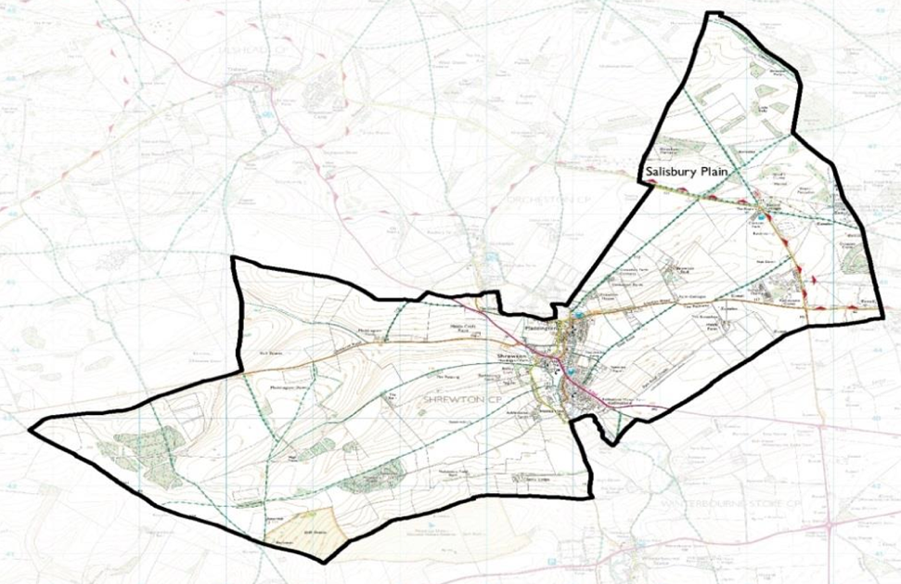
Figure 1 Shrewton Neighbourhood Plan Designated Area

Methodology

The approach to site assessment is based on the Government’s Planning Practice Guidance. The relevant sections are:

1. Housing and Economic Land Availability Assessment (March 2015).
2, Neighbourhood Planning (updated February 2018).
3. Locality’s Neighbourhood Planning Site Assessment Toolkit.

Although a neighbourhood plan is at a smaller scale than a Local Plan, the criteria for assessing the suitability of sites for housing are still appropriate. In this context, the methodology for identifying sites and carrying out the site appraisal is presented below.

Task 1: Identifying sites for inclusion in the assessment
There is very little suitable space within the settlement boundary and therefore, all the sites proposed (except S150) are adjacent to the existing settlement boundary and on ‘greenfield’ land. The settlement is bounded to the North by Orcheston Parish, to the west by MOD land and to the south and east, at slightly greater distances, by the World Heritage Site and the A303. All land with potential to accommodate residential development within, adjoining, or well related to the existing settlement boundary of Shrewton has been identified and assessed through the Wiltshire Strategic Housing and Employment Land Availability Assessment (SHELAA) process.
The SHELAA represents the principal evidence base for identifying potential housing sites in Wiltshire and includes:
- Sites promoted by landowners and developers,
- Sites identified by the local planning authority,
- Sites adjoining settlement boundaries,
- Both greenfield and previously developed land.
For Shrewton, the SHELAA identifies all realistic land parcels that could form a logical extension to the settlement, considering physical, environmental, policy, and infrastructure constraints. Wiltshire Council last assessed the sites in the SHELAA in 2020. The sites under consideration were:

SHELAA | Title | Included by settlement | Discounted by settlement | Total area/ha
3384 | Land off Common (site 1) |  |  | 2.3485
3385 | Land off Common (site 2) |  |  | 0.4764
S77 | Land Nettwood Farm Nett Road | Yes |  | 2.587
S113 | Land to Rear of Hinde's Meadow | Yes |  | 1.0427
S146 | Land South of the Gibbet |  | Yes | 19.275
S150 | Land North of Rollestone Manor | Yes |  | 10.3953
S151 | Land South of Nettley Farm | Yes |  | 4.858
S152 | Land at Rollestone Manor |  | Yes | 0.282
S154 | Land N of Nett Rd & S of London Rd |  | Yes | 13.3517
209 | Land to the North of the Hollows | Yes |  | 5.9671
S1066 | Adjacent Yew Tree Cottage |  |  | 0.8213
S1067 | Land off Maddington Street |  |  | 1.129
148 | Land West of Tanners Lane |  | Yes
149 | Land West of the Butts |  | Yes
153 | Land E of Piggeries & S of London Rd |  | Yes
Table 1 2017 SHELAA Sites
These are shown below:
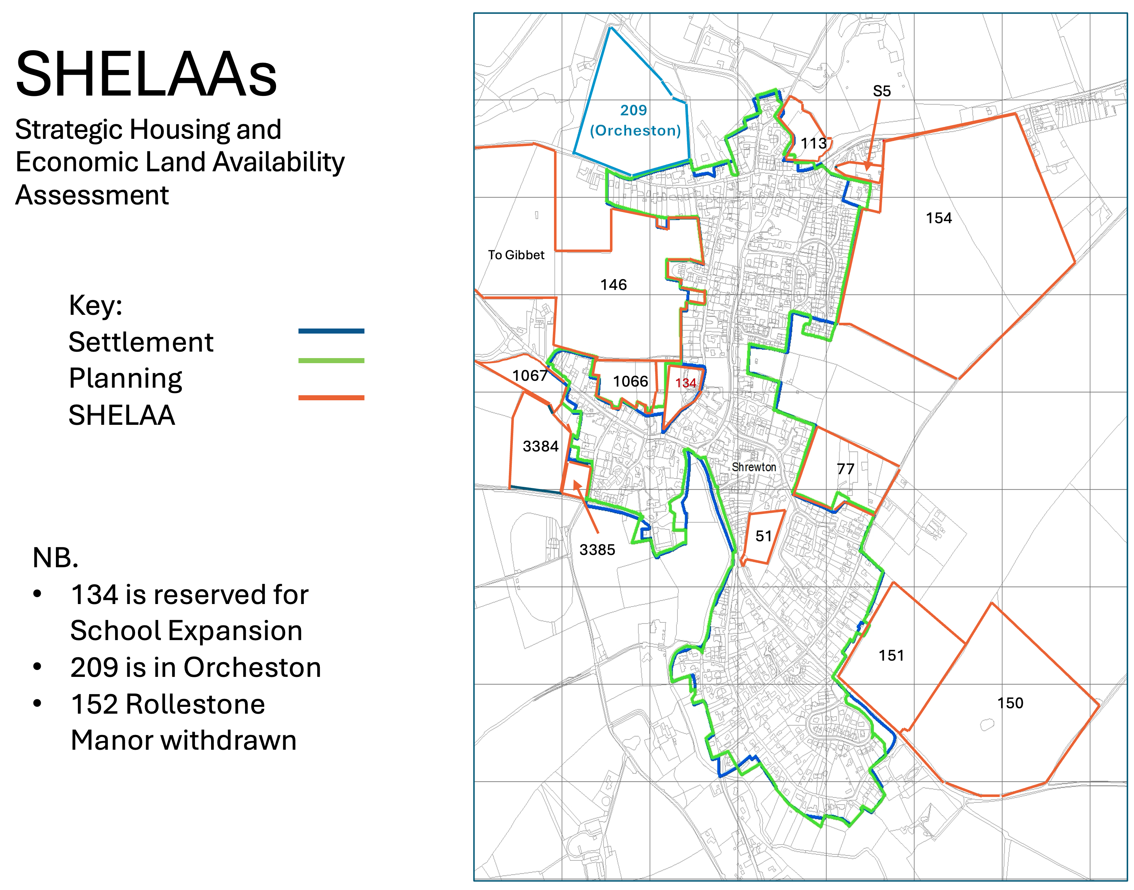
Figure 2 2017 SHELAA Sites
Wiltshire Council assessed all the sites in the SHELAA for suitability, availability, deliverability and achievability and allocated the following sites as sites of interest – S146, S150, S151, S154, S1067. These are shown below.
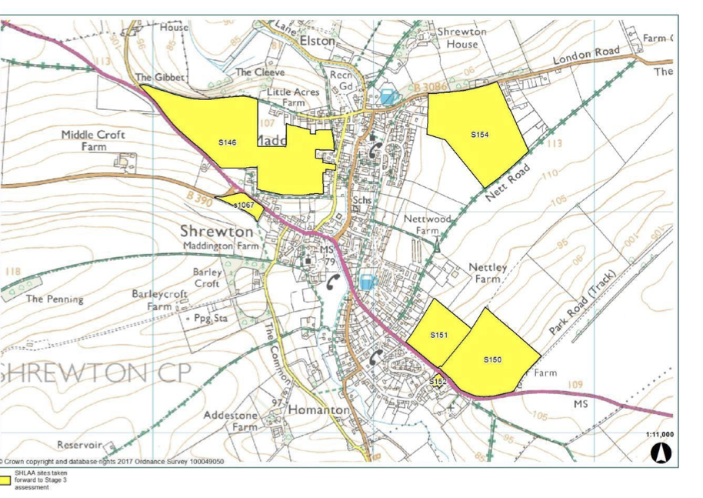
Figure 3 2017 SHELAA Sites of Interest

The Neighbourhood Plan Steering Group reviewed the full SHELAA site list for the parish and confirmed that no additional sites exist within or immediately adjoining the settlement boundary that are not already captured within the SHELAA. No Call for sites was made. This approach is consistent with Planning Practice Guidance for neighbourhood planning, which does not require a Call for Sites where reasonable alternatives are already identified.

Task 2: Gathering information for site assessments
A site appraisal pro-forma, developed by Locality, has been used to assess potential sites for allocation in the neighbourhood plan. It is based on the Government’s National Planning Practice Guidance, the Site Assessment for Neighbourhood Plans: A Toolkit for Neighbourhood Planners (Locality, 2015) and the knowledge and experience of the Neighbourhood Plan Steering Group. The purpose of the pro-forma is to enable a consistent evaluation of each site against an objective set of criteria.

Site surveys were carried out in person through 2025 to understand the site context and
relationship with the existing settlement, visually assess site constraints and opportunities and assess the impact of development on the surrounding built environment and landscape.

Task 3: Site Assessment
The desktop assessment and site survey information is drawn together into a set of individual site assessments (Annex A). A set of summary tables which allows comparison of the sites and enables a ‘traffic light’ rating of all sites to be made, based on the site constraints and opportunities. The rating scale shows whether a site is appropriate for allocation – i.e. the site is suitable, available and achievable for the proposed use:
Green is for sites free from constraints, or which have constraints that can be resolved, and therefore are suitable for development. Sites rated green are appropriate for allocation for proposed use in a neighbourhood plan (if it is viable).

Amber sites have constraints that would need to be resolved or mitigated, so the site is potentially appropriate for allocation (if also viable) for proposed use in a neighbourhood plan.

Red sites are unsuitable for development and therefore not appropriate to allocate for proposed use in a neighbourhood plan.

Task 4: Indicative housing capacity
The capacity of a site is the amount of development that would be appropriate for that site, depending on location, the surrounding area and the site context, e.g. existing buildings or trees. Where a figure has been put forward for the site by a landowner or site promoter, or by the Council, this has been reviewed to understand if it is appropriate. If a figure has not already been put forward for the site, a figure has been provided to indicate the amount of development that would be appropriate for the site.

Where a capacity figure does not already exist, an indicative capacity has been calculated by applying a density assumption based on the size of the site and the prevailing density of existing development schemes. This is in line with the SHELAA methodology, which sets out density ranges for each of the Housing Market Areas in Wiltshire. In the south HMA dwellings per hectare (dph), with lower densities applying on larger sites. Depending on the size of the site, a ratio has then been applied to account for the area of the site which is likely to be required for non-residential use (e.g. supporting infrastructure, community or other facilities), as set out in SHELAA Table 2.1 (reproduced below).

The indicative capacity allows for a consistent comparison of site capacities but are used solely for comparative purposes and do not represent a policy target or design expectation. Site-specific constraints, as well as discussions with the landowner over the type of development being proposed and the need for other uses to be accommodated on the site, should inform the number of homes to be delivered on any sites allocated in the Neighbourhood Plan. Indicative capacities

Note that the densities in Table 2.1 are for an urban setting and would be out of character in a rural village like Shrewton. Actual densities for Shrewton would be significantly less, in keeping with the social and environmental objectives.

Table 2.1 Calculation of site ‘developable area’ and density

Site area | Developable area  (% of gross site area) | Indicative density (dph)
Up to 0.4 ha | 90% | 37 to 47
0.4 ha to 2 ha | 80% | 37 to 47
2 ha to 10 ha | 75% | 37 to 47
Over 10 ha | 50% | 37 to 47

Policy Context

National Policy

The National Planning Policy Framework (NPPF) (Dec 2024) sets out the Government’s planning policies for England and how these should be applied. It provides a framework
within which locally prepared plans can provide for housing and other development
in a manner. It is also at the heart of the Governments plans to deliver 1.5 million homes in the life of this parliament. Preparing and maintaining up-to-date plans should be seen as a priority in meeting this objective. To support this ambition the NPPF states:

‘Achieving sustainable development means that the planning system has three
overarching objectives, which are interdependent and need to be pursued in
mutually supportive ways (so that opportunities can be taken to secure net gains
across each of the different objectives):

a) an economic objective – to help build a strong, responsive and competitive
economy, by ensuring that sufficient land of the right types is available in the right
places and at the right time to support growth, innovation and improved
productivity; and by identifying and coordinating the provision of infrastructure;

b) a social objective – to support strong, vibrant and healthy communities, by
ensuring that a sufficient number and range of homes can be provided to meet
the needs of present and future generations; and by fostering well-designed,
beautiful and safe places, with accessible services and open spaces that reflect
current and future needs and support communities’ health, social and cultural
well-being; and

c) an environmental objective – to protect and enhance our natural, built and
historic environment; including making effective use of land, improving
biodiversity, using natural resources prudently, minimising waste and pollution,
and mitigating and adapting to climate change, including moving to a low carbon
economy.

All plans should promote a sustainable pattern of development that seeks to: meet the development needs of their area; align growth and infrastructure; improve the environment; mitigate climate change and adapt to its effects.

Local authorities are required to deliver local plans that must include strategic policies to address each local planning authority’s priorities for the development and use of land in its area. Strategic policies should, as a minimum, provide for objectively assessed needs for housing, infrastructure, community facilities and conservation and enhancement of the natural, built and historic environment as well as any needs that cannot be met within neighbouring areas. Plans should make explicit which policies are strategic policies
Neighbourhood plans should support the delivery of strategic policies contained in local plans or spatial development strategies; and should shape and direct development that is outside of these strategic policies.

Of note for the Shrewton Neighbourhood Plan is the policy:

‘For neighbourhood plans, the policies in this Framework will apply for the purpose of
preparing neighbourhood plans from 12 March 2025 unless a neighbourhood plan
proposal has been submitted to the local planning authority under Regulation 15 of
the Neighbourhood Planning (General) Regulations 2012 (as amended) on or before
the 12 March 2025.’

Wiltshire Planning Policy

Wiltshire Core Strategy (2015)
The Wiltshire Core Strategy (WCS) was adopted in January 2015 and sets the overarching planning policy framework for Wiltshire to 2026. The following policies are of relevance to the Neighbourhood Plan site assessment. An interactive map of spatial policies from the Core Strategy is available on the Wiltshire Council website⁸.
Core Policy 1 establishes the settlement hierarchy for Wiltshire. Shrewton is classed as a ‘Large Village’ in the hierarchy. Large Villages are defined as “settlements with a limited range of employment, services and facilities. Development at Large and Small Villages will be limited to that needed to help meet the housing needs of settlements and to improve employment opportunities, services and facilities”.
Core Policy 2: Delivery Strategy seeks to deliver a minimum housing requirement of 42,000 dwellings over the plan period to 2026. Sites for development in line with the Area Strategies will be identified through subsequent Site Allocations Development Plan Documents and by supporting communities to identify sites through neighbourhood planning.
Within the limits of development, as defined on the policies map, there is a presumption in favour of sustainable development at the Principal Settlements, Market Towns, Local Service Centres and Large Villages. Other than in circumstances as permitted by other policies within this plan, development will not be permitted outside the limits of development, as defined on the policies map. The limits of development may only be altered through the identification of sites for development through subsequent Site Allocations DPDs and Neighbourhood Plans.
Core Policy 4: Spatial Strategy for Amesbury Community Area states that over the plan period (2006 to 2026), 17 ha of new employment land and approximately 2,785 new homes will be provided. About 2,440 should occur at Amesbury (including Bulford and Durrington), including land identified at Kings Gate, Amesbury for strategic growth. Approximately 345 homes will be provided in the rest of the Community Area. Growth in the Amesbury Community Area over the plan period may consist of a range of sites in accordance with Core Policies 1 and 2.

Core Policy 43: Providing affordable homes states that sites of ten or more dwellings should include at least 30% affordable housing provision. The provision of affordable housing may vary on a site-by-site basis taking into account evidence of local need, mix of affordable housing proposed and, where appropriate, the viability of the development.
Core Policy 44: Rural exceptions sites allow an exception to policy to allow for a practical approach to the provision of affordable housing to be delivered in conjunction with parish councils and working with local communities and other parties, provided that:
- the proposal has clear support from the local community
- the housing is being delivered to meet an identified and genuine local need
- the proposal is within, adjoining or well related to the existing settlement
- environmental and landscape considerations will not be compromised
- the proposal consists of 10 dwellings or fewer
- employment and services are accessible from the site
- its scale and type is appropriate to the nature of the settlement and will respect the character and setting of that settlement
- the affordable housing provided under this policy will always be available for defined local needs, both initially and on subsequent change of occupant.
In exceptional circumstances, a proportion of market housing may be considered appropriate where it can be demonstrated that the site would be unviable, as an exception site that meets the above criteria, without cross- subsidy.
Core Policy 50: Biodiversity and Geodiversity ensures that development proposals must demonstrate how they protect features of nature conservation and geological value. All development proposals should incorporate appropriate measures to avoid and reduce disturbance of sensitive species and habitats throughout the lifetime of the development, and direct and indirect impacts upon local sites should be avoided through sensitive site location and layout, and by maintaining sufficient buffers and ecological connectivity with the wider environment. Damage or disturbance to local sites will generally be unacceptable, other than in exceptional circumstances and subject to the criteria detailed in the policy.
Core Policy 51: Landscape seeks to protect, conserve and enhance Wiltshire’s distinctive landscape character. Proposals should be informed by and sympathetic to the distinctive character areas identified in the relevant Landscape Character Assessment(s) and any other relevant assessments and studies.
Core Policy 52: Green Infrastructure requires development to make provision for the retention and enhancement of Wiltshire’s green infrastructure network (i.e. amenity green space, woodland, green corridors, and allotments) and shall ensure that suitable links to the network are provided and maintained and to make provision for accessible open spaces (such as parks, play areas, sports pitches and allotments) in accordance with the adopted Wiltshire Open Space Standards. If damage or loss of existing green infrastructure is unavoidable, the creation of new or replacement green infrastructure will be required.
Core Policy 58: Ensuring the conservation of the historic environment states that development should protect, conserve and where possible enhance the historic environment. Designated heritage assets and their settings should be conserved, and where appropriate enhanced in a manner appropriate to their significance.

Wiltshire Housing Site Allocations Plan (2020)
The Wiltshire Housing Site Allocations Plan (HSAP) was adopted in February 2020. The HSAP sits alongside the WCS as part of the adopted Development Plan for Wiltshire. In this context the HSAP has two purposes. Firstly, to review and revise settlement boundaries where necessary and secondly to allocate new sites for housing to ‘ensure a rolling five-year supply in each of Wiltshire’s three HMAs over the plan period to 2026’. The geographic scope of the HSAP is the entire WCS plan area with the exception of the Chippenham Community Area.
The HSAP does not make any site allocations in Shrewton Parish. However, in accordance with WCS Core Policy 1, the HSAP does define the settlement boundary for Shrewton. As per the supporting text of WCS Core Policy 1, development outside the settlement boundary ‘will be strictly controlled’ and there is ‘a general presumption against development outside the defined limits’ of the settlements, although recent applications for development adjacent to the settlement boundary have been approved.
Defined settlement boundaries can be altered through a Neighbourhood Plan where this will help achieve the plan’s objectives, subject to consultation with the Local Planning Authority and conformity with the Local Plan. For example, the settlement boundary could be amended through the Neighbourhood Plan to recognise a site allocation in the Neighbourhood Plan.

The Rural Housing Requirements

This 2023 document noted (P152) that:

It is proposed that the Local Plan requirement for Shrewton should be set at 82
dwellings, with a residual figure of 72 dwellings over the remainder of the plan
period to 2038. However, due to the likely limited options available to address
phosphorus neutrality in the short term, planned development at Shrewton may not
be achievable until the latter end of the Local Plan period, unless development
proposals can demonstrate an acceptable bespoke mitigation strategy.

The 2026 LPR Examination Housing Completions and Commitments update (Table 4.8)(2) does not list residual numbers but seems to indicate a residual requirement of 72 ( Housing Growth (82) minus Completions (5) and commitments (5)).

For the purposes of this Neighbourhood Plan, the residual housing requirement for Shrewton is taken to be 72 dwellings, based on the Wiltshire Local Plan Review Examination Update (January 2026)

Wiltshire Local Plan Review

The Wiltshire Local Plan Review (LPR) will replace the adopted WCS and HSAP. The LPR underwent Issues and Options consultation in late 2017 and a further informal consultation in late 2018. The plan is in examination with an expected release of late 2026 or 2027. The policies in the WCS and the LPR were reviewed for their impact on Shrewton. The updated residual housing requirement for Shrewton remains at 72 homes for the period of the LPR (2016- 2038)
At the time of writing, it is recognised that the Local Plan Review does not address the new mandatory housing requirements as set out in the NPPF. The Wiltshire Council plan for a further revision of the Local Plan to address this issue has not yet been released.

Wiltshire Local Plan Review Update
Wiltshire council and the Planning Inspectors have been exchanging letters since Nov about the future direction of the Local Plan. On 27th Feb 2026 the Inspectors wrote back to Wiltshire Council and gave them two options:

- withdraw the Local Plan from examination or
- request that the Inspectors draft a final report (which would recommend non-adoption)

They don’t require an immediate decision but have requested the council to provide an anticipated timescale for formally advising them of their decision on their options by 13 March 2026.

In addition, the Ministry of Housing, Communities and Local Government letter to Wiltshire Council on 15 January 2026 states ‘requires you to give notice of preparing a new plan by 30 June 2026, and to submit your Gateway 1 self-assessment by 31 October 2026 under the new plan-making system’.

We do not know the WC decision yet.

However, the supporting documents for the LPR remain the most up to date available and will be used to support the NP until they are updated.

Neighbourhood Plan

Neighbourhood plans should support the delivery of strategic policies contained in local plans or spatial development strategies; they should shape and direct development that is outside of these strategic policies.

This can include allocating sites, the provision of infrastructure and community facilities at a local level, establishing design principles, conserving and enhancing the natural and historic environment and setting out other development management policies.

Site Assessment Summary

Shrewton Background

Shrewton is a rural settlement bounded to the north by Orcheston Parish and the Salisbury Plain Training Area SPTA (Special Protected Area (SPA), to the west by the SPTA and to the south and east by the A303 and the World Heritage Site. In addition, the village is within the Hampshire Avon Special Area of Conservation (SAC) and the River Till Site of Special Scientific Interest runs through the village (placing all potential development sites within the Till Impact Risk Zone (IRZ) of 2km). All potential sites are greenfield locations at the edge of the settlement and lie within the catchment of these internationally and nationally designated ecological assets. As such, none are free from significant constraint. The Shrewton Waste Water Recycling Centre (SWWRC) upgrade, which is due to be complete by 2030, needs to be complete before development can occur, unless a bespoke solution is proposed. It is considered that bespoke mitigation, in addition to other planning obligations, would adversely affect the viability of all the sites. None of the sites meet the NPPF definition of deliverable within 5 years due to wastewater and nutrient constraints. The assessment therefore compares medium-term developable options.

None of these existing plans or measures will meeting the regulatory water quality limits for chalk streams, which are mandatory across the Hampshire Avon SAC and other chalk streams. The planned water quality targets for improvement are at least 8 times worse than those required by legislation and government regulations. The potential for significant long term and irreparable environmental damage to the ecology and biodiversity, as well as to the chalk aquifers is currently a ministerial concern and the Under Secretary of State, Defra, has committed in writing to ensuring that these water quality regulatory requirements are enforced and not breached. This poses a further constraint on development in the Shrewton area, and, to date, no suitable mitigations have been identified.

Traffic congestion, and the associated risks it poses to safety, health and the infrastructure of the village is a major concern. Shrewton is situated at a key crossroads on the A360 and is impacted by high volumes of traffic, much of which is passing through the village on its way to larger towns or as a route across Salisbury Plain. Eastbound and westbound traffic diverting off the A303 to avoid congestion routes through and meets in the village. This volume of traffic greatly exceeds the accepted limits for B roads. The absence of mitigation schemes for these issues, especially following the cancellation, in July 2024, of the Stonehenge Tunnel project, leaves the village vulnerable to further traffic disruptions. Major retail and employment opportunities are located to the south and east of the village and therefore sites (on the south and east side of the village) that do not require routine travel through the village to access these facilities will be preferred. All future development in Shrewton must include a comprehensive assessment and mitigation for traffic congestion issues, and the attendant risks.

The impact of traffic on the village infrastructure and the safety and quality of life of villagers is the number one concern for most villagers.

In the absence of a definitive site-specific Agricultural Land Classification(ALC) survey and given that all reasonable alternatives are subject to similar uncertainty, agricultural land quality is not considered a differentiating factor between sites at this stage

All development in Shrewton will need to provide effective sustainable mitigation to these common issues.

Earlier Assessments

The 2020 SHELAA reduced the sites under consideration in Shrewton to 5: S146, S150, S151, S154, S1067. At the time the HSAP SA noted that all these sites were considered ‘Red” and not taken forward to Stage 4.
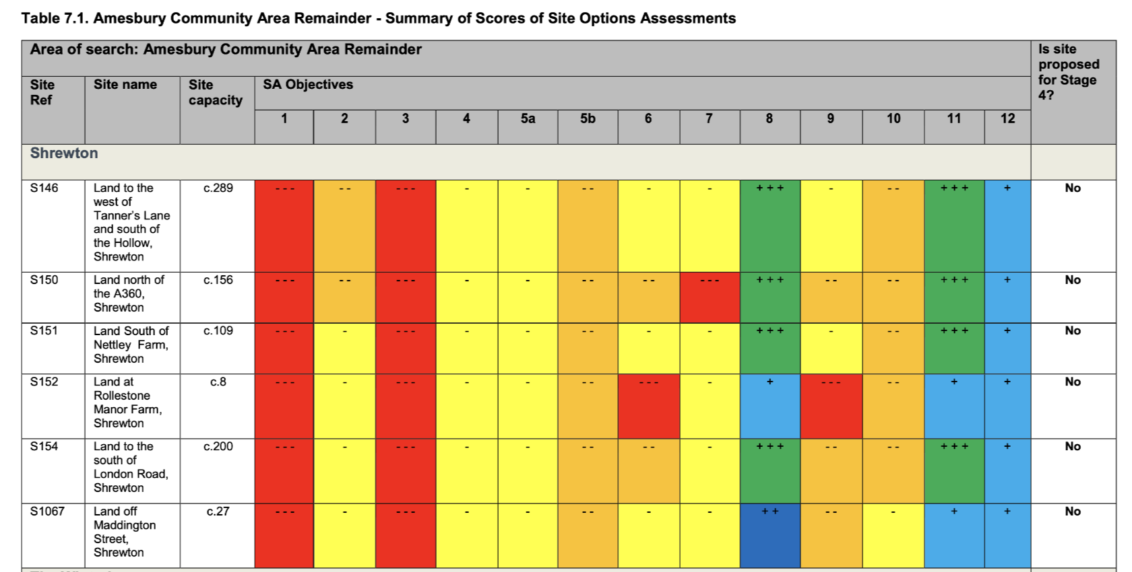

Current Assessment

The 2024 NPPF introduced a new standard method for calculating housing requirements and makes these targets mandatory. For Shrewton to contribute and have a say in where development should take place, a further review of potential sites becomes essential.

The NPSG has revisited all accessible data on previous assessments and concluded that a local review of the 5 remaining sites (S146,S150,S151,S154 and S1067) should be undertaken to identify sites where, once other mitigations have been considered, the village would support future development. S1066 was added to this list due to its proximity to the perceived ‘centre’ of the village (Till Orchard Surgery /Co-Op) and these 6 sites were re-assessed in more detail.

S1067 was withdrawn from further consideration due to concerns about local surface water flooding that were supported by the landowner. S1066 was withdrawn due to challenges with access to the A360, access via Tanners Lane was not considered practical or desirable; the lack of a developer and the landowner has yet to commit to its inclusion. Finally, S150 was withdrawn as; unless S151 is developed first S150 represents an outlier that is not connected to the settlement boundary and it scores less well for sustainability than S151 and is therefore the least sustainable of the sites considered.

The three remaining potential housing sites (S146, S151 and S154) were assessed to inform the selection of site options for the Shrewton Neighbourhood Plan.

The assessment therefore focuses on relative suitability, scale, and timing, rather than absolute capacity.

The following definitions, based on PPG, are used throughout:
- Available: landowner willing and able to release land
- Achievable: development technically possible in principle
- Deliverable: capable of being delivered within 5 years are used

Full details of the individual sites are at Annex A. The table below summarises those assessments:

Table 2 Summary of Sites
Factor | S146 – West of Tanners Lane | S151 – South of Nettley Farm | S154 – South of London Road
Gross site area | 19.3 ha | 4.9 ha | 13.4 ha
Existing land use | Greenfield | Greenfield | Greenfield
Indicative capacity (Neighbourhood Plan-scale) | ~12 dwellings | ~72 dwellings | ~72 dwellings
Developer promoted capacity | 12 (partial site) | 85–148 | Up to 190
Relationship to settlement | Adjacent, village edge | Adjacent, southern edge | Adjacent, eastern edge
Overall rating | Red (later-term only) | Amber | Amber
Likely delivery window | 6–10+ years | 6–10 years | 6–10 years

Environmental & Ecological Constraints
Factor | S146 | S151 | S154
SAC / SPA / SSSI IRZ | Yes – very close to River Till SSSI (~140m) | Yes – River Till SSSI (~400m) | Yes – River Till SSSI (~500m)
Nutrient neutrality | Required | Required | Required
Wastewater constraints | Major (upgrade not before ~2030) | Major (upgrade not before ~2030) | Major (upgrade not before ~2030)
Flood risk | Low | Low | Low
Ecological network role | High sensitivity | High sensitivity | High sensitivity
Relative ecological constraint | Very High | High | High

Landscape, Visual & Heritage Considerations

The template guidance says that this section should be answered based on existing evidence or by a qualified landscape consultant. Funding is not available for a qualified landscape consultant and therefore the South Wiltshire Landscape Character Assessment has been used to form a judgement. Should a more detailed assessment or verification be required then funding for a landscape consultant or advice sought from Wiltshire Planning Authority,

Factor | S146 | S151 | S154
Landscape sensitivity | Medium–High (valley landscape) | Medium–High (chalk downland) | Medium–High (chalk downland)
Visual sensitivity | Medium | High | High
Key views affected | Village & valley views | Panoramic downland views | Panoramic views; WHS setting
Heritage constraints | Limited | Limited | Development would be confined to lower slopes of the site, avoiding elevated land that contributes to the setting of the Stonehenge World Heritage Site, in accordance with the WHS Supplementary Planning Document
Scope for mitigation | Limited | Moderate (reduced scale) | Moderate (lower slopes only)

Accessibility & Transport
Factor | S146 | S151 | S154
Vehicular access | Narrow Tanners Lane | A360 – major constraint | B3086 – manageable with mitigation
Pedestrian access | Good (sub-500m to services) | Moderate (>850m, steep gradients) | Moderate (>1km, some links)
Sustainability of location | Best of three | Weak | Moderate
Highways mitigation needed | Moderate | High | Moderate

Availability & Viability
Factor | S146 | S151 | S154
Availability | Yes | Yes | Yes
Ownership issues | None | None | None
Abnormal costs | High (ecology, access, wastewater) | High (A360 access, ecology) | High (landscape, ecology, drainage)
Deliverable in 0–5 yrs | No | No | No

Narrative

Site S146 – Land west of Tanners Lane
Site S146 is a large greenfield site on the western edge of the village, adjacent to sensitive valley landscapes and close to the River Till SSSI. While the site benefits from relatively good proximity to village services, it is subject to multiple overlapping constraints, including:
- Very close proximity to the River Till SSSI
- The only site that is in the River Till Source Protection Zone
- Medium–high landscape sensitivity and important village views
- Narrow and constrained vehicular access via Tanners Lane
- Use of land with social and amenity value
Due to environmental and infrastructure challenges that are difficult to mitigate, only a very limited portion of the site could realistically accommodate development without unacceptable harm. As a result, Site S146 is not considered suitable for allocation within the Neighbourhood Plan period, although it may have potential as a long-term reserve site beyond 2030.

Site S151 – Land south of Nettley Farm
Site S151 is a smaller site located on the southern edge of Shrewton, adjacent to the A360 corridor. The site is affected by:
- High visual sensitivity within the chalk downland landscape
- Poor accessibility to village services (over 850m walking distance with steep gradients)
- Significant highway constraints relating to safe access onto the A360
Although development could potentially be accommodated at a reduced scale aligned with the village’s residual housing requirement. The site is less sustainable with more difficult access to village facilities than S154 and, with access onto the A360 would require substantial highway and landscape mitigation. Delivery is unlikely before the medium term.

Site S154 – Land south of London Road
Site S154 lies to the east of the village and offers a logical extension to existing development along London Road. This extension would fill a gap between the village and the isolated houses further out on the London Rd. While the site is visually sensitive and lies within the wider setting of the Stonehenge World Heritage Site, evidence indicates that:
- Development could be confined to lower slopes, avoiding sensitive ridgelines
- Landscape and heritage impacts may be mitigated through design and green infrastructure
- Vehicular access via the B3086 is more manageable than at other sites.
Although ecological and wastewater constraints remain, Site S154 performs more strongly in comparative terms, offering the best balance between capacity, mitigation potential, and settlement integration. Delivery is unlikely before the medium term.

Comparative Assessment and Preferred Site
All three sites are constrained by strategic ecological and waste water issues that limit early delivery. However, when assessed comparatively:

Site S146 performs poorly due to extreme environmental sensitivity, it is the closest site to the SSSI and the only site in the SSSI SPZ. The access would be through Tanners Lane that has difficult junctions at either end. There is limited realistic capacity.

The key considerations for the remaining two sites are tabulated below

 | Site 151 | Site 154 | Notes
SAC/SPA constraints | Yes | Yes
landscape sensitivity | Medium–High | Medium–High | S151 on major access route through village (A360) and more ‘visible’
Delivery timescales | 6-10 yrs | 6-10 yrs
Capacity | ~72 | ~72 | Limited to meet the residual housing requirement
Ecological Impacts | Greater than S154 but less than S146 | Least impact of the three sites | S154 is furthest from the SSSI
Proximity to services | 850m | >1km | Similar but S154 would have access via existing footpaths
Settlement Integration | Extends the village along the A360 towards WHS | Links the existing London Rd housing with village
Access | A360 – tree lined and limited visibility splays | B3086 relatively open with reasonable sightlines

Site S151 is constrained by accessibility to the A360, the approach is tree lined with only limited visibility onto this major route through the village. This position gives the site greater visual impact and distance from the village ‘centre’ makes it less sustainable than the other sites. The site would extend the village to the south and closer to the WHS.

Site S154 performs best overall, offering a coherent settlement edge and clearer mitigation opportunities. It also presents an opportunity to extend the village to include the outlying houses on the London Rd and thus contribute to better inclusion and safety on this stretch of the B3086. Access to the B3086 is relatively open with good sightlines.

Conclusion.
None of the sites around Shrewton are considered to meet the NPPF requirements for deliverable (within 5 yrs) due to the waste water constraints. Meeting existing environmental and traffic infrastructure requirements will impose additional costs on all sites and will need to be considered when judging viability. The NP regulations allow the village to look to the medium, and longer term, delivery and the sites were considered on this basis and on the potential benefits to the village.
Based on the evidence, and the assumption that Shrewton will be allocated a mandatory housing target, the site options process allocates Site S154 to meet Shrewton’s residual housing requirement, with development expected in the 6–10-year period, subject to the resolution of ecological and waste water constraints.
Site S151 is identified as a reasonable alternative but is not allocated due to weaker sustainability performance. Site S146 is not allocated and is treated as a longer-term contingency site only.

Annex A to 2026 Shrewton Site Options Report

This template is from the Locality toolkit and has been used in numerous NPs to produce site option reports. It is used, unaltered, in our assessment to provide the common base line that consultees and the examiners will expect from a NP Site Options Report that is used to determine site allocations in a NP.

S146 Land to the West of Tanners Lane and South of the Hollow

Detail | Assessment
Land to the west of Tanners Lane and south of the Hollow
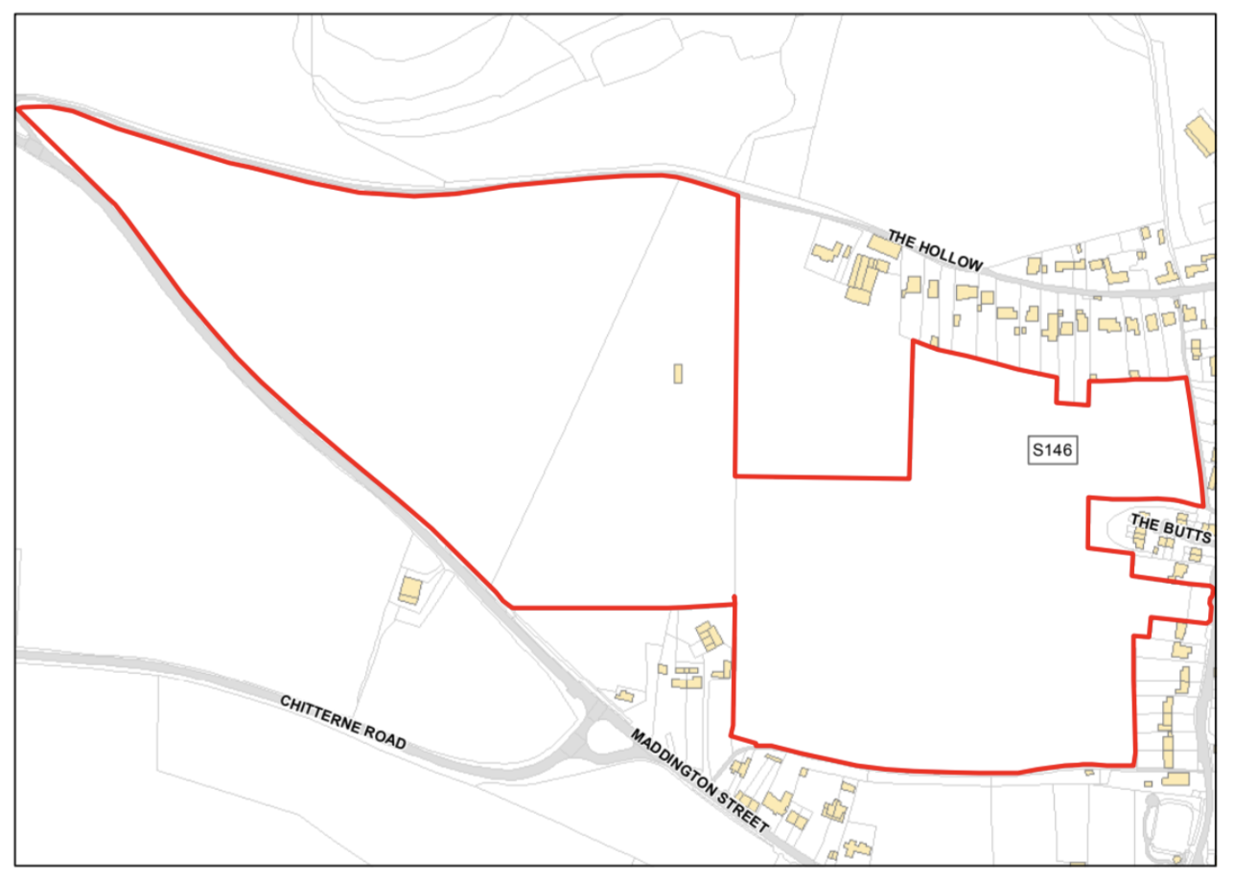 | 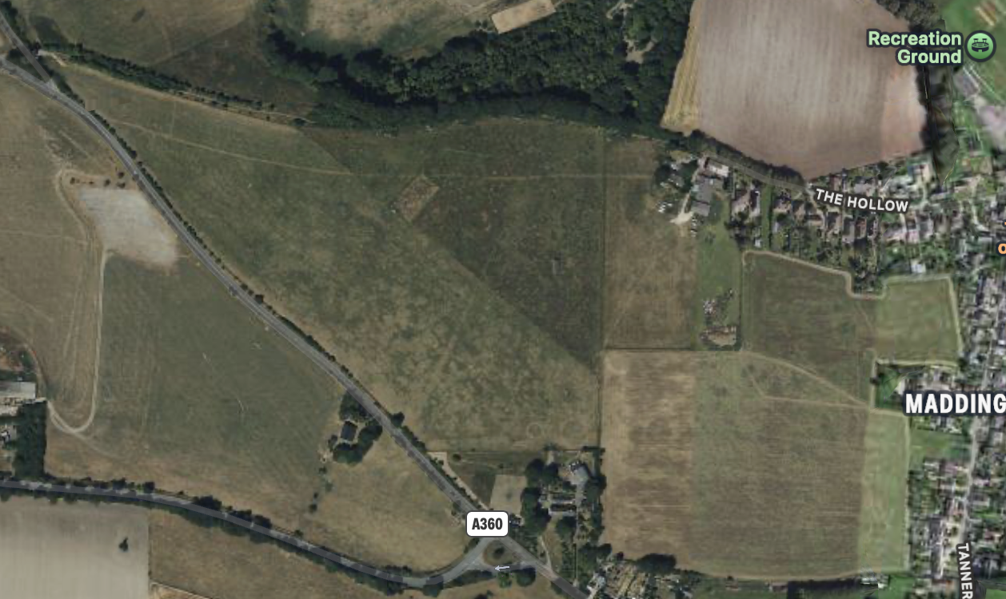
Site Address / Location | Land to the west of Tanners Lane and south of the Hollow
Gross Site Area (Hectares) | 19.275ha (only a limited portion potentially suitable for development)
SHLAA/SHELAA Reference (if applicable) | Shrewton – S146
Existing land use | Greenfield
Land use being considered, if known (e.g. housing, community use, commercial, mixed use) | Residential - Potential allocation in NP
Site identification method / source  (e.g. SHELAA, Call for Sites consultation, identified by neighbourhood planning group) | SHELAA02SHELAAAppendix51AmesburyCommunityArea.pdf-5.pdf
Planning history  (Live or previous planning applications/decisions) | No comments in SHELAA02SHELAAAppendix51AmesburyCommunityArea.pdf-5.pdf. nor on Wiltshire Planning Site (Jan 2026)
Landowner estimate of development capacity (if known) | 12 Developer proposed on part of site. (Shaded Green) Restrictions due to ecology, landscape and visual constraints.
Neighbouring uses | Residential, Village edge / open countryside; adjoining residential streets around Tanners Lane and The Hollow; adjoining agricultural land.

Assessment of Suitability

Environmental Constraints
Indicator of Suitability | Assessment
Site is predominantly, or wholly, within or adjacent to the following statutory environmental designations:  Ancient Woodland  Area of Outstanding Natural Beauty (AONB)  Biosphere Reserve  Local Nature Reserve (LNR)  National Nature Reserve (NNR)  National Park  Ramsar Site  Site of Special Scientific Interest (SSSI)  Special Area of Conservation (SAC)  Special Protection Area (SPA)  Yes/ No/ Unknown  Does the site fall within a SSSI Risk Impact Zone and would the proposed use/development trigger the requirement to consult Natural England?  Yes/ No/ Unknown | Yes  Site is within SPA_5km, SAC_5km, SSSI_2km, SPZ (Source Protection Zone). Significant mitigations will be required to support any development on this site.  Within 2km of River Till SSSI (~140m at closest point (adjacent to Tanners Lane). Development requires Natural England consultation (Source https://magic.defra.gov.uk/MagicMap.html SSSI Risk Impact Zones. (Accessed Jan 2026)  This is the only site under consideration that will also need to mitigate for impacts on the SPZ.
Site is predominantly, or wholly, within or adjacent to the following non statutory environmental designations:  Green Infrastructure Corridor  Local Wildlife Site (LWS)  Public Open Space  Site of Importance for Nature Conservation (SINC)  Nature Improvement Area  Regionally Important Geological Site  Other  Yes/ No/ Unknown | No
Site is predominantly, or wholly, within Flood Zones 2 or 3?  See guidance notes:  Flood Zone 1: Low Risk  Flood Zone 2: Medium Risk  Flood Zone 3 (less or more vulnerable site use): Medium Risk  Flood Zone 3 (highly vulnerable site use): High Risk | Flood Zone 1: Low Risk  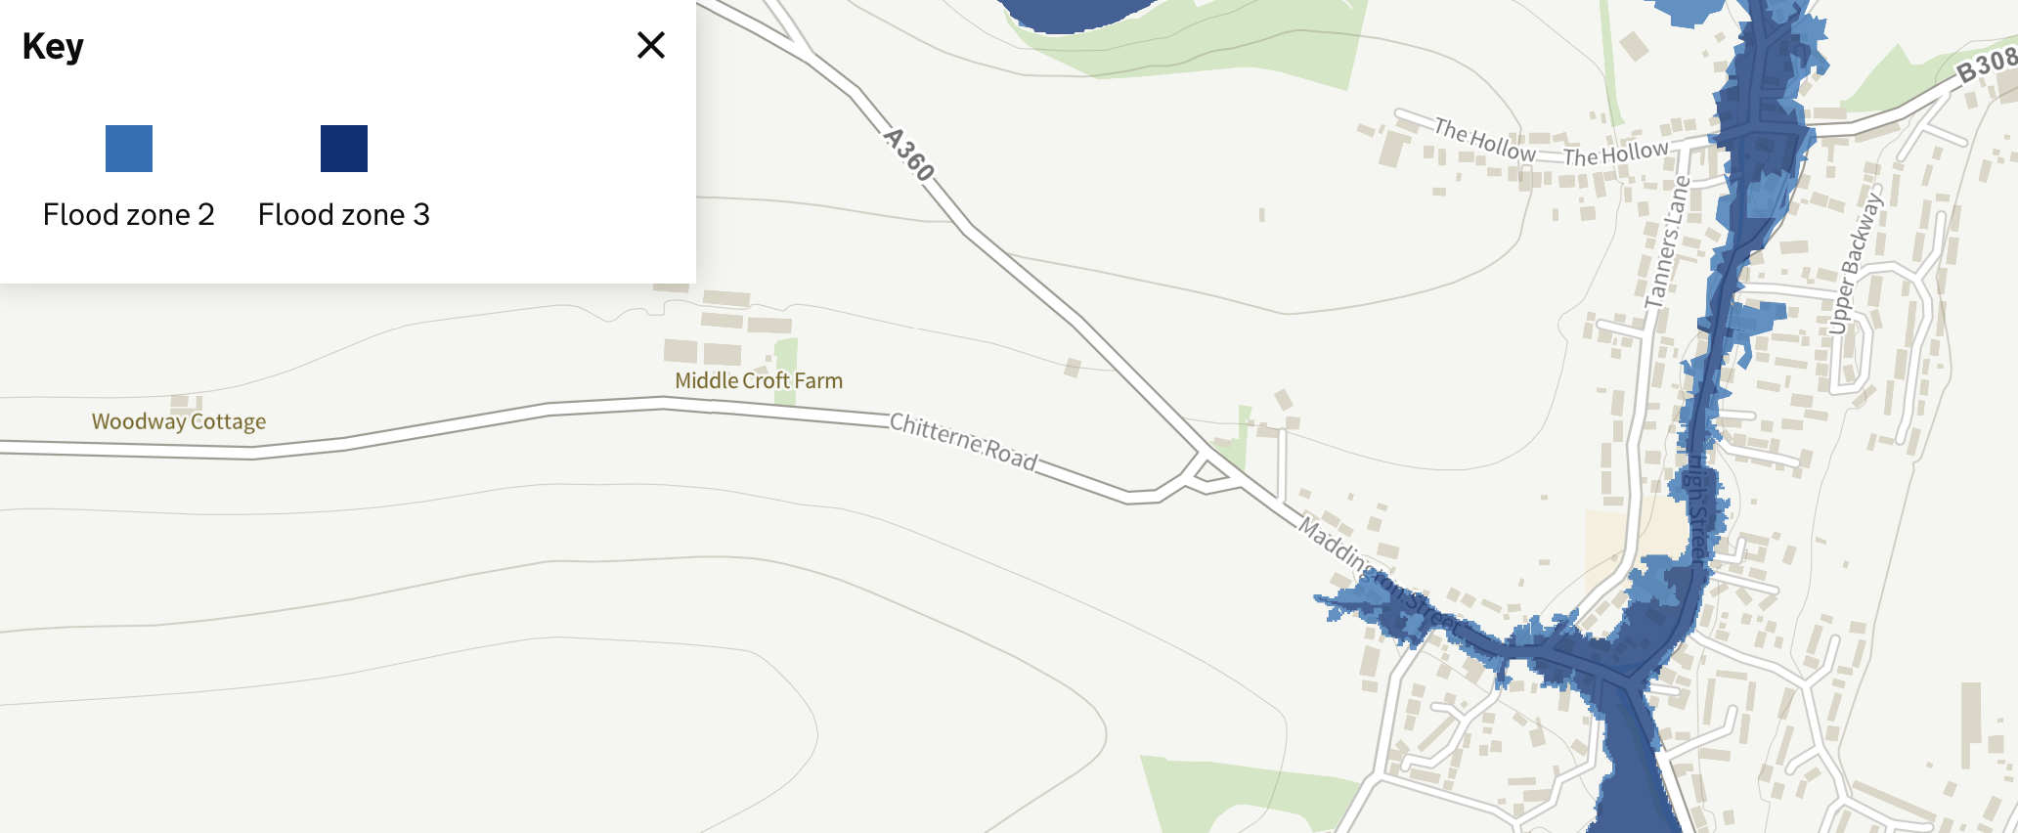
Site is at risk of surface water flooding?  See guidance notes:  Less than 15% of the site is affected by medium or high risk of surface water flooding – Low Risk  >15% of the site is affected by medium or high risk of surface water flooding – Medium Risk | Low Risk  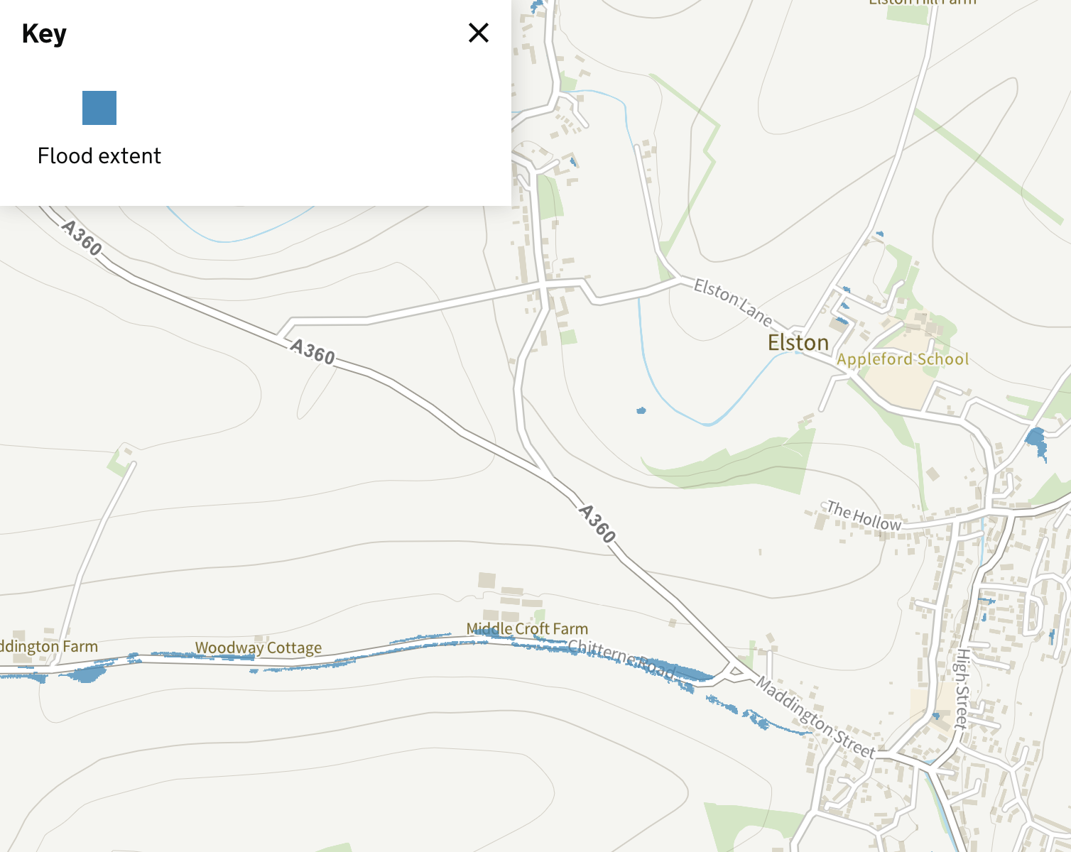
Is the land classified as the best and most versatile agricultural land (Grades 1, 2 or 3a)  Yes / No / Unknown | Unknown:  There is a conflict between the Rural Housing Requirements (Jul 2023): ALCG3 and the SHELAA(2017): ALCG1.  Local farming assessment suggests 3B.  A formal assessment may be required if BMV becomes a deciding factor.
Site contains habitats with the potential to support priority species?  Does the site contain local wildlife-rich habitat:  Is the site part of:  A wider ecological network (including the hierarchy of international, national and locally designated sites of importance for biodiversity);  wildlife corridors (and stepping stones that connect them); and/or  An area identified by national and local partnerships for habitat management, enhancement, restoration or creation?  Yes / No / Unknown | Yes  1. The site is within the Hampshire Avon SAC and the Salisbury Plain SPA both of which are considered of European importance.  2. The site is also within the Impact Risk Zone for the River Till SSSI which is considered of national importance.  Strategic Environmental Assessment and Habitats Regulation Assessment are both likely to be required.
Site is predominantly, or wholly, within or adjacent to an Air Quality Management Area (AQMA)?  Yes / No / Unknown | No

Physical Constraints
Indicator of Suitability | Assessment
Is the site:  Flat or relatively flat  Gently sloping or uneven  Steeply sloping | Gently sloping or uneven
Is there existing vehicle access, or potential to create vehicle access to the site?  Yes / No / Unknown | Yes – via Tanners Lane which is a narrow road with access via difficult junctions at both ends. Noting that detailed highways assessment would be required.
Is there existing pedestrian/cycle access, or potential to create pedestrian/cycle access to the site?  Pedestrian?  Yes / No / Unknown  Cycle?  Yes / No / Unknow | Yes  Yes
Are there any known Tree Preservation Orders on the site?  Yes / No / Unknown | No
Are there veteran/ancient or other significant trees within or adjacent to the site? Are they owned by third parties?  Significant trees?  Yes, within / Yes, adjacent / No / Unknown  Potentially veteran or ancient trees present?  Yes, within / Yes, adjacent / No / Unknown  Owned by third parties?  Yes / No / Unknown | 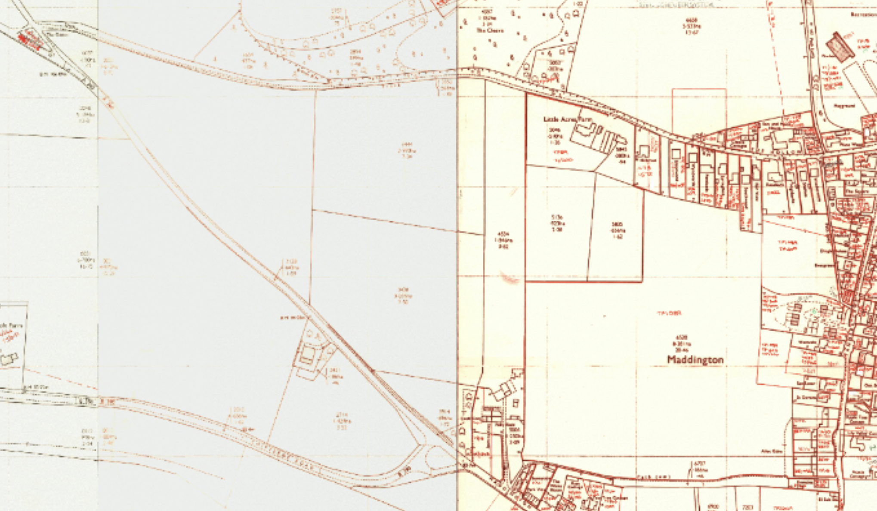  No  No  No
Are there any Public Rights of Way (PRoW) crossing the site?  Yes / No / Unknown | 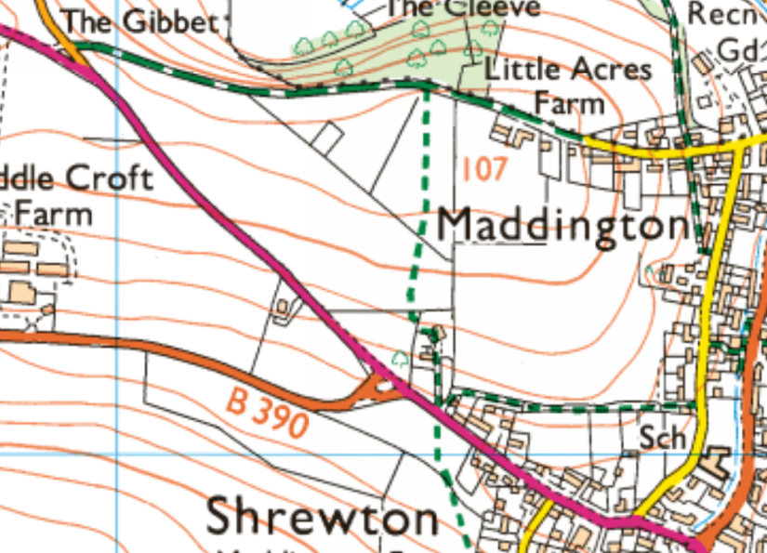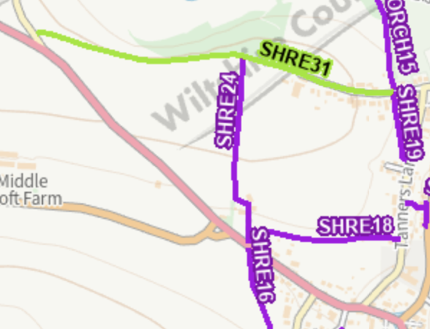  Yes. SHRE 24. However, none through proposed development.
Is the site likely to be affected by ground contamination?  Yes / No / Unknown | No
Is there any utilities infrastructure crossing the site i.e. power lines/pipe lines, or is the site in close proximity to hazardous installations?  Yes / No / Unknown | Yes. Powerlines
Would development of the site result in a loss of social, amenity or community value?  Yes / No / Unknown | Yes  Upper reaches of this open ground form an important view both across the site into the village and from points within the village .  Potential – loss of Best Most Valuable agricultural land.  GUL National Charity uses most of the upper area of the site for grazing.  Subject to Key View Report.

Accessibility
Factor |  |  | Guidance
Distances to community facilities and services should be measured using walking routes from the centre of each site to each facility. Additional facilities can be added to the list. The distances are based on the assumption that 400m is equal to approximately 5 minutes’ walk. This can be measured using Google Maps:
What is the distance to the following facilities (measured from the edge of the site) | Distance  (metres) | Comments  Measured from lower 1/3rd of site as development would not aim to fill the site
Town / local centre / shop | <400m  400-1200m  >1200m | 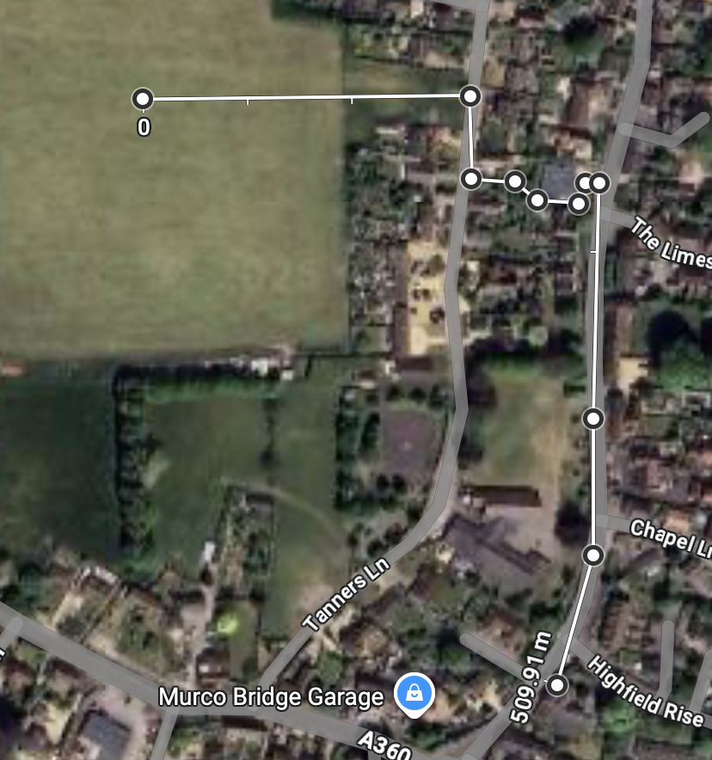  509m
Bus /Tram Stop | <400m  400-800m  >800m | Adjacent to Co-op. 480m
Train station | <400m  400-1200m  >1200m | Salisbury >1200m
Primary School | <400m  400-1200m  >1200m | 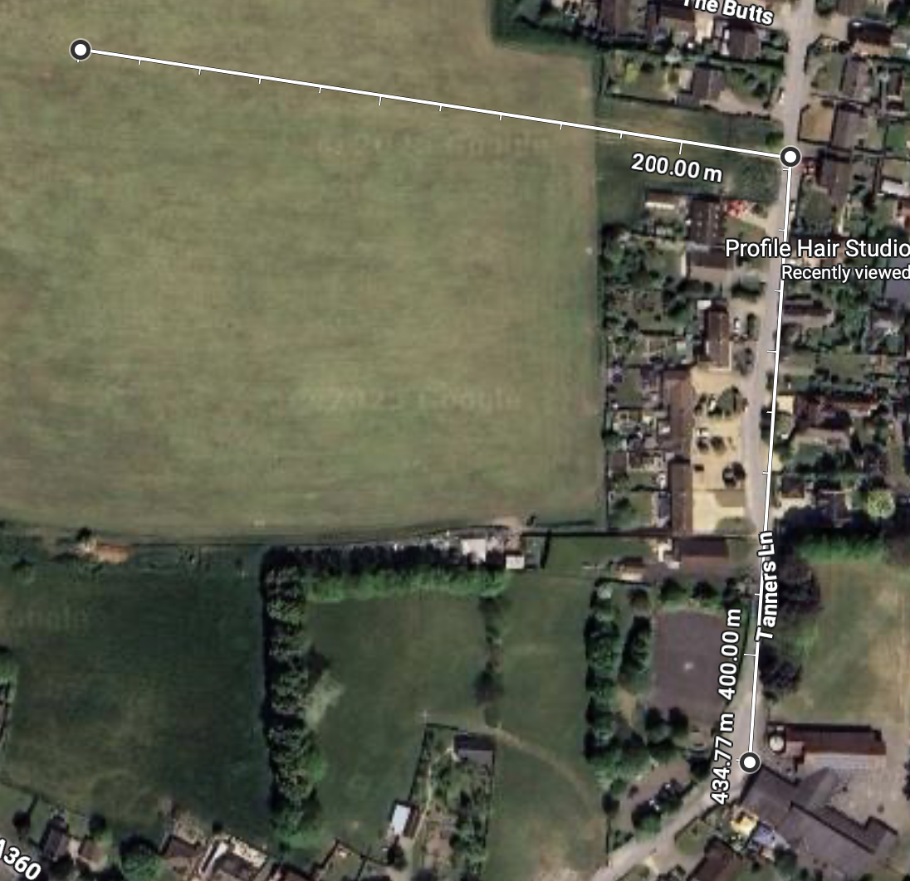  437m
Secondary School | <1600m  1600-3900m  >3900m | Amesbury >3900m
Open Space / recreation facilities | <400m  400-800m  >800m | 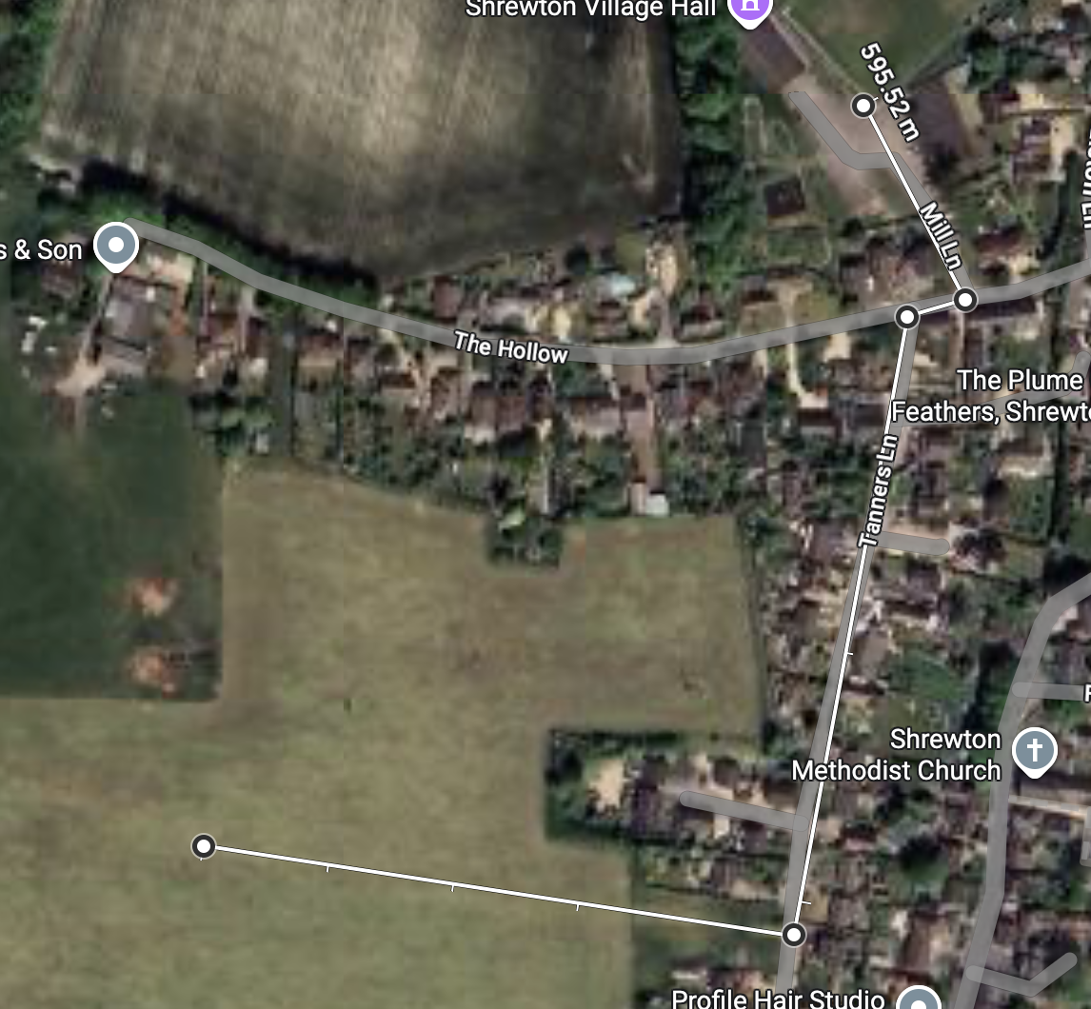  595m
Cycle Route | <400m  400-800m  >800m | 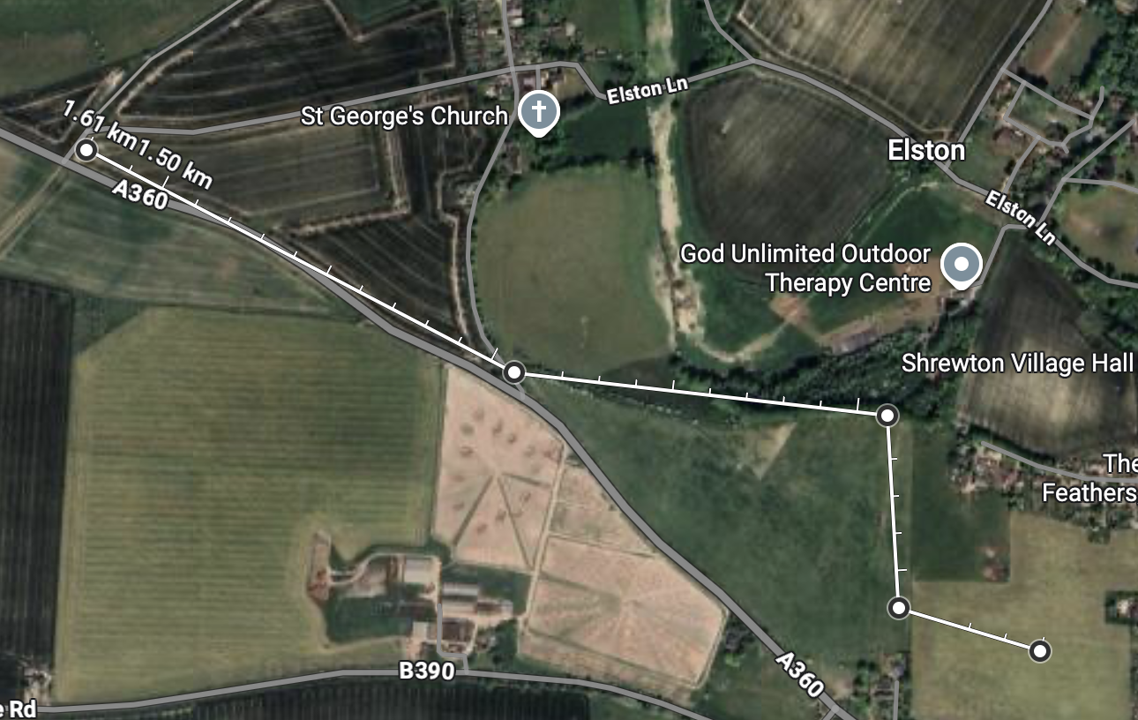  King Alfred’s Way >800m

Landscape and Visual Constraints
This section should be answered based on existing evidence (see guidance notes) or by a qualified landscape consultant.
Indicator of Suitability | Assessment
Is the site low, medium or high sensitivity in terms of landscape?  Low sensitivity: the site has few or no valued features, and/or valued features that are less susceptible to development and can accommodate change.  Medium sensitivity: the site has many valued features, and/or valued features that are susceptible to development but could potentially accommodate some change with appropriate mitigation.  High sensitivity: the site has highly valued features, and/or valued features that are highly susceptible to development. The site can accommodate minimal change. | Medium - High  Constrained small development to protect landscape  Landscape Character Sensitivity  The relatively enclosed nature of the valley, with its intricate pattern sinuous woodland belts and small pasture fields, contributes to overall moderate to high sensitivity. Further inherent landscape sensitivities include dispersed, scattered settlement pattern, visible archaeological features and historic water meadows along the floodplain.  Subject to Landscape and Visual Impact Assessment Report
Is the site low, medium or high sensitivity in terms of visual amenity?  Low sensitivity: the site is visually enclosed and has low intervisibility with the surrounding landscape, and/or it would not adversely impact any identified views.  Medium sensitivity: the site is somewhat enclosed and has some intervisibility with the surrounding landscape, and/or it may adversely impact any identified views.  High sensitivity: the site is visually open and has high intervisibility with the surrounding landscape, and/or it would adversely impact any recognised views. | Medium  The site is somewhat enclosed and has some intervisibility with the surrounding landscape, and/or it may adversely impact any identified views  Visual Sensitivity  Along the valley floor, sense of enclosure is strong, as a result of intermittent sinuous belts of woodland. From the valley floor, views are generally contained to the valley corridor and lower valley sides. From the higher slopes, however, intervisibility with surrounding open Chalk Downland is strong, with open views from the valley across this larger-scale landscape. Overall visual sensitivity is considered to be moderate.  Subject to Key Views Report

Heritage Constraints
Indicator of Suitability | Assessment
Would the development of the site cause harm to a designated heritage asset or its setting?  Directly impact and/or mitigation not possible  Some impact, and/or mitigation possible  Limited or no impact or no requirement for mitigation | Limited or no impact or no requirement for mitigation
Would the development of the site cause harm to a non-designated heritage asset or its setting?  Directly impact and/or mitigation not possible  Some impact, and/or mitigation possible  Limited or no impact or no requirement for mitigation | Limited or no impact or no requirement for mitigation

Planning policy constraints
Indicator of Suitability | Assessment
Is the site in the Green Belt?  Yes / No / Unknown | No
Is the site allocated for a particular use (e.g. housing / employment) or designated as open space in the adopted and / or emerging Local Plan?  Yes / No / Unknown | No  The site was not assessed further following Wiltshire Housing Site Allocations Plan Sustainability Appraisal Report February 2020
Are there any other relevant planning policies relating to the site? | None in SHELAA or Wiltshire Council Planning Site (Jan 2026)
Is the site:  Greenfield  A mix of greenfield and previously developed land  Previously developed land? | Greenfield
Is the site within, adjacent to or outside the existing built-up area?  Within the existing built-up area (infill)?  Adjacent to and connected to the existing built-up area?  Outside and not connected to the existing built-up area? | Adjacent to and connected to the existing built-up area
Is the site within, adjacent to or outside the existing settlement boundary (if one exists)?  Within the existing settlement boundary?  Adjacent to and connected to the existing settlement boundary?  Outside and not connected to the existing settlement boundary? | Adjacent to and connected to the existing settlement boundary
Would development of the site result in neighbouring settlements merging into one another?  Yes / No / Unknown | No
Is the size of the site large enough to significantly change the size and character of the existing settlement?  Yes / No / Unknown | No. Landscape, ecology and water mitigation requirements restrict site to a very small development.

Assessment of Availability
Indicator of Availability | Assessment
Is the site available for development?  Yes / No / Unknown. | Yes. Owner consent and developer vision document
Are there any known legal or ownership problems such as unresolved multiple ownerships, ransom strips, tenancies, or operational requirements of landowners?  Yes / No / Unknown. | No
Is there a known time frame for availability?  Available now / 0-5 years / 6-10 years / 11-15 years. | Available now. However, see SWWRC constraint that likely precludes development before 2030.

Viability
Indicators of Viability | Assessment
Is the site subject to any abnormal costs that could affect viability, such as demolition, land remediation or relocating utilities?  Yes / No / Unknown.  What evidence is available to support this judgement? | Yes.  There are plans for the local sewage treatment works to be upgraded to improve nutrient management, but this is not likely to be complete until 2030. Due to the likely limited options available to address phosphorus neutrality in the short term, planned development at Shrewton may not be achievable until the latter end of the Local Plan period, unless development proposals can demonstrate an acceptable bespoke mitigation strategy.  Development at these settlements (including Shrewton) could potentially contribute towards locally significant effects on the River Avon SAC through abstraction and mitigation could be required.  Viability assessment should be repeated to take account of the significant constraint mitigations required.
Conclusion | Assessment
Summary of key development constraints affecting the site | Site S146 is subject to multiple, significant environmental, infrastructure and landscape constraints, which materially limit its suitability for allocation for development within the early part of the plan period. These include:  - Proximity to River Till SSSI (approximately 140m at closest point) and location within associated SSSI Impact Risk Zones, requiring consultation with Natural England.  - Within River Till SPZ – further examination of the potential impact will be required to support development.  - Location within the Hampshire Avon SAC catchment and Salisbury Plain SPA, meaning that development would be subject to Habitats Regulations Assessment and the demonstration of nutrient neutrality and avoidance of likely significant effects.  - Wastewater infrastructure constraints, with the Shrewton Waste Water Recycling Centre upgrade not expected to be completed until circa 2030, limiting the ability to demonstrate deliverability (within 5 years).  - Landscape and visual sensitivity assessed as medium to high, with important views into and out of the village and a sensitive valley landscape character.  - Access constraints, with vehicular access reliant on Tanners Lane, a narrow residential road, and proximity to the village primary school raising highway safety concerns that would require mitigation.  - Potential loss of best and most versatile agricultural land, with conflicting ALC evidence and no definitive site-specific survey to resolve this issue at present.  The site is not unsuitable in principle, but its suitability is significantly constrained by ecological designations, landscape sensitivity, access limitations and agricultural land considerations. Only a very limited area of the site could realistically accommodate development without unacceptable harm.
What is the estimated development capacity of the site? | Developer proposed 12
What is the likely timeframe for development?  (0-5 / 6-10 / 11-15 / 15+ years) | Developable: In short-term (6-10)  Due to the combination of nutrient neutrality requirements, the need for bespoke mitigation, and the wastewater infrastructure upgrade timetable, the site cannot be considered deliverable within the first five years of the plan period.  While development may become achievable later in the plan period, this is dependent on:  - Completion of wastewater infrastructure upgrades,  - Resolution of nutrient mitigation requirements, and  - The ability to demonstrate acceptable landscape, ecological and highway mitigation without undermining viability.
Other key information | Potential access issues.  Available - Yes  Achievable - Yes (residential)  Deliverable: - No
Overall rating (Red/Amber/Green)  The site is suitable, available and achievable  The site is potentially suitable, available and achievable  The site is not currently suitable, available and achievable | The site is not currently suitable, it is available and could be achievable after 2030.
Summary of justification for rating | Taking all factors into account, Site S146 is assessed as:  Suitable in principle but subject to substantial constraints; available; and potentially achievable only in the later part of the plan period.  The site does not meet the tests of deliverability required for allocation within this Neighbourhood Plan but may have a role in meeting longer-term housing needs should current constraints be resolved.

Conclusions

S151 Land South of Nettley Farm, Shrewton
Detail | Assessment
Land South of Nettley Farm, Shrewton
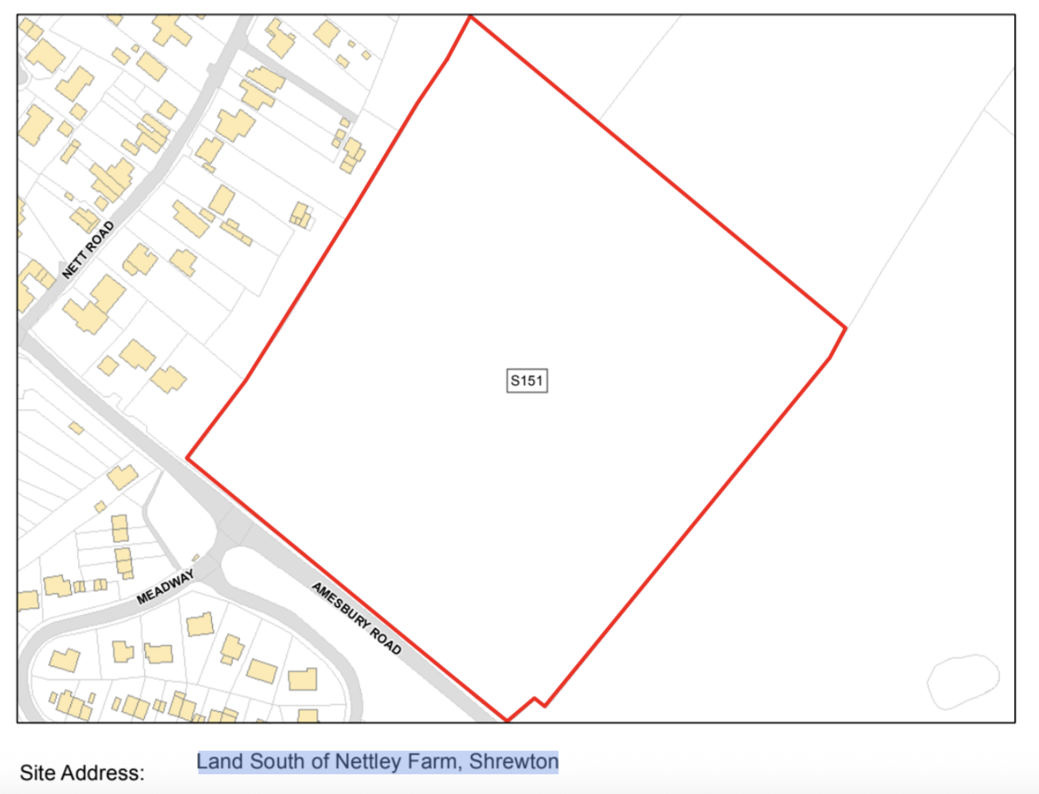 | [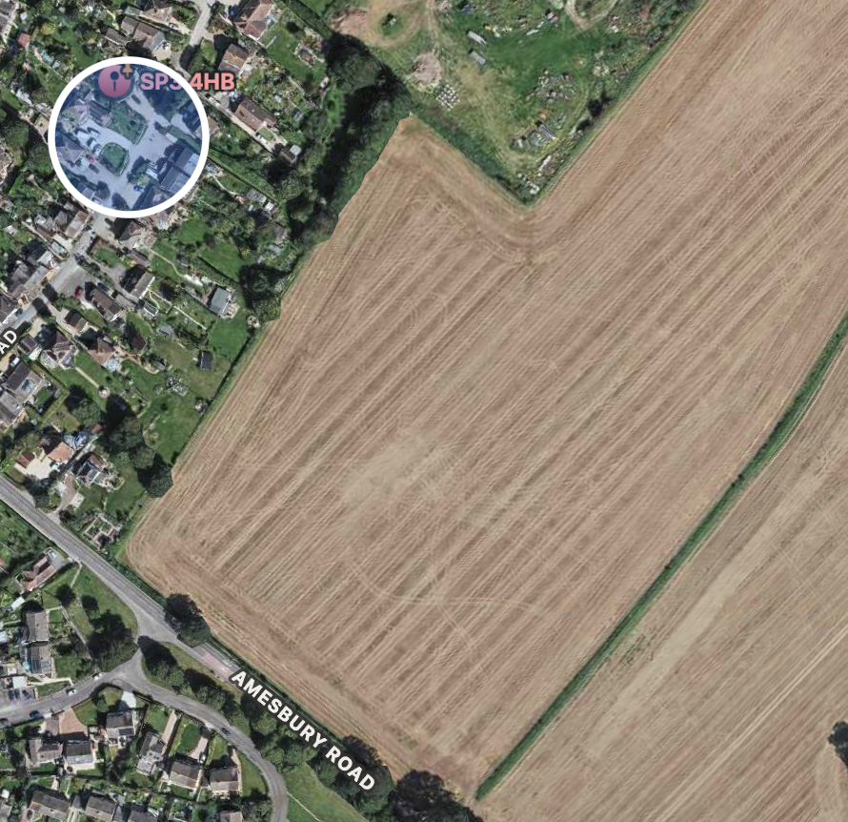
Site Address / Location | Land South of Nettley Farm, Shrewton
Gross Site Area (Hectares) | 4.858ha (100% suitable)
SHLAA/SHELAA Reference (if applicable) | Shrewton - S151
Existing land use | Greenfield
Land use being considered, if known (e.g. housing, community use, commercial, mixed use) | Residential
Landowner estimate of development capacity (if known) | 148 residential. Developer proposed 85. Residual Housing Requirement 72
Site identification method / source  (e.g. SHELAA, Call for Sites consultation, identified by neighbourhood planning group) | WC Documents  SHELAA02SHELAAAppendix51AmesburyCommunityArea.pdf-5.pdf
Planning history  (Live or previous planning applications/decisions) | None recorded on WC Site. Developer pre-application advice not listed. See Developer Document
Neighbouring uses | Adjacent to A360 corridor; nearby residential areas off Nett Road/Meadway; open countryside.

Assessment of Suitability

Environmental Constraints
Indicator of Suitability | Assessment
Site is predominantly, or wholly, within or adjacent to the following statutory environmental designations:  Ancient Woodland  Area of Outstanding Natural Beauty (AONB)  Biosphere Reserve  Local Nature Reserve (LNR)  National Nature Reserve (NNR)  National Park  Ramsar Site  Site of Special Scientific Interest (SSSI)  Special Area of Conservation (SAC)  Special Protection Area (SPA)  Yes/ No/ Unknown  Does the site fall within a SSSI Impact Risk Zone and would the proposed use/development trigger the requirement to consult Natural England?  Yes/ No/ Unknown | Site is within SPA_5km, SAC_5km, SSSI_2km, Significant mitigations will be required to support any development on this site.  Within 2km of River Till SSSI (~400m at closest point . Development requires Natural England consultation (Source https://magic.defra.gov.uk/MagicMap.html as this is within the SSSI Risk Impact Zones. (Accessed Jan 2026)
Site is predominantly, or wholly, within or adjacent to the following non statutory environmental designations:  Green Infrastructure Corridor  Local Wildlife Site (LWS)  Public Open Space  Site of Importance for Nature Conservation (SINC)  Nature Improvement Area  Regionally Important Geological Site  Other  Yes/ No/ Unknown | No
Site is predominantly, or wholly, within Flood Zones 2 or 3?  See guidance notes:  Flood Zone 1: Low Risk  Flood Zone 2: Medium Risk  Flood Zone 3 (less or more vulnerable site use): Medium Risk  Flood Zone 3 (highly vulnerable site use): High Risk | Low Risk  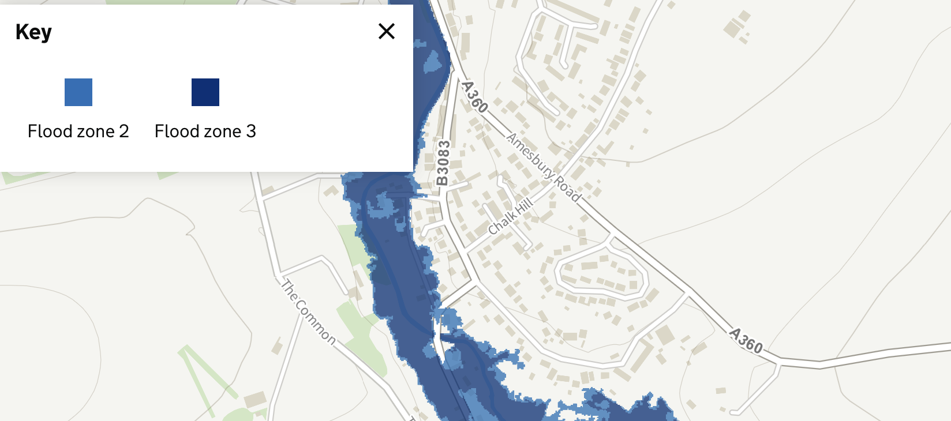
Site is at risk of surface water flooding?  See guidance notes:  Less than 15% of the site is affected by medium or high risk of surface water flooding – Low Risk  >15% of the site is affected by medium or high risk of surface water flooding – Medium Risk | Low Risk  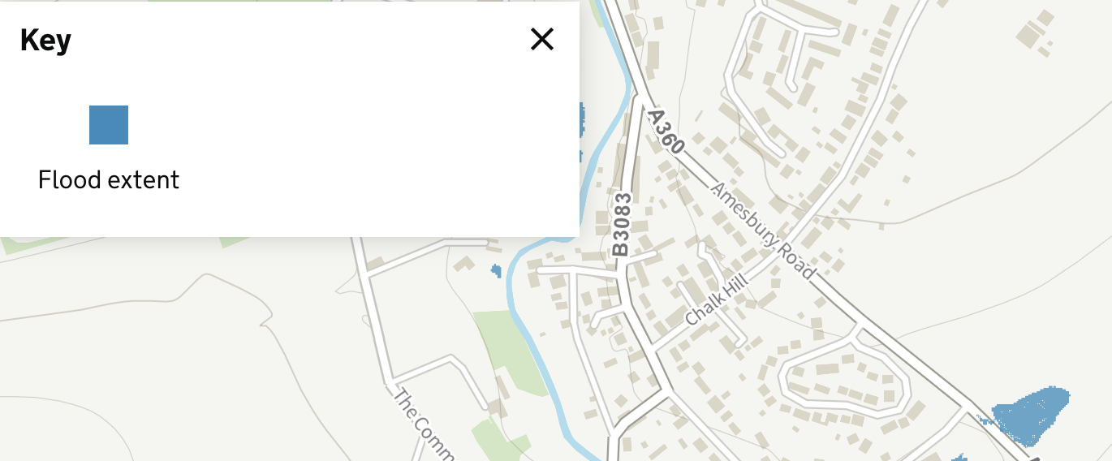
Is the land classified as the best and most versatile agricultural land (Grades 1, 2 or 3a)  Yes / No / Unknown | Unknown:  There is a conflict between the Rural Housing Reqts (Jul 2023): ALCG3 and the SHELAA: ALCG1.  Local farming assessment suggests 3B  A formal assessment may be required if BMV becomes a deciding factor.
Site contains habitats with the potential to support priority species?  Does the site contain local wildlife-rich habitats?  Is the site part of:  A wider ecological network (including the hierarchy of international, national and locally designated sites of importance for biodiversity);  wildlife corridors (and stepping stones that connect them); and/or  An area identified by national and local partnerships for habitat management, enhancement, restoration or creation?  Yes / No / Unknown | Yes  1. The site is within the Hampshire Avon SAC and the Salisbury Plain SPA both of which are considered of European importance.  2. The site is also within the Risk Impact Zone for the River Till SSSI which is considered of national importance.  Strategic Environmental Assessment and Habitats Regulation Assessment are both likely to be required.
Site is predominantly, or wholly, within or adjacent to an Air Quality Management Area (AQMA)?  Yes / No / Unknown | No

Physical Constraints
Indicator of Suitability | Assessment
Is the site:  Flat or relatively flat  Gently sloping or uneven  Steeply sloping | Gently sloping or uneven  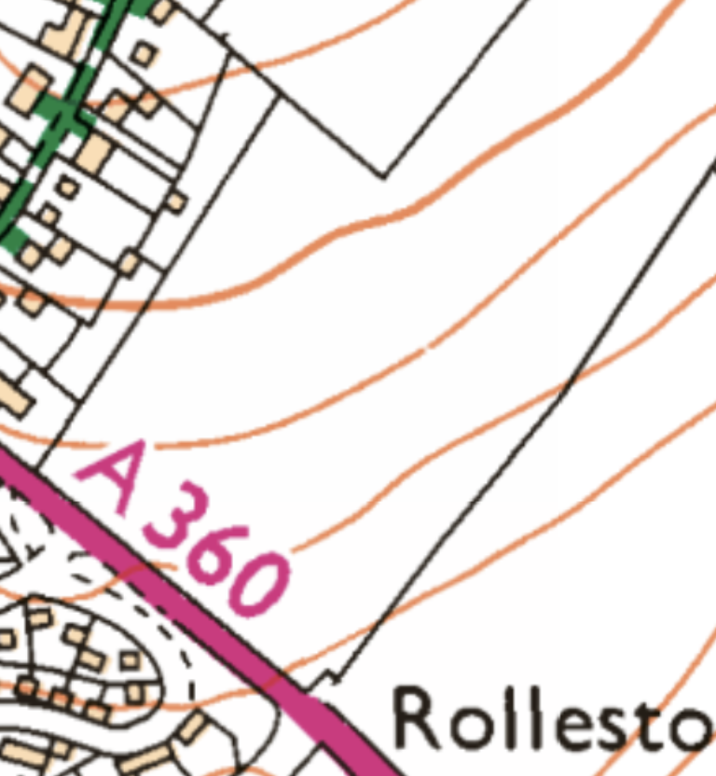
Is there existing vehicle access, or potential to create vehicle access to the site?  Yes / No / Unknown | Yes  Major constraint: safe access onto A360. Sightlines and tree lined approaches.  Mitigation: Any development of the site would be required to be supported by a proportionate Transport Assessment or Transport Statement, including junction capacity and safety analysis for access. Any necessary mitigation to be agreed with the local highway’s authority
Is there existing pedestrian/cycle access, or potential to create pedestrian/cycle access to the site?  Pedestrian?  Yes / No / Unknown  Cycle?  Yes / No / Unknown | Yes  Constraint. Safe non-vehicular routes alongside the A360 require study. Currently they would need to cross and recross A360. Routes to the majority of village facilities are around 1km and involve considerable elevation changes.
Are there any known Tree Preservation Orders on the site?  Yes / No / Unknown | No
Are there veteran/ancient or other significant trees within or adjacent to the site? Are they owned by third parties?  Significant trees?  Yes, within / Yes, adjacent / No / Unknown  Potentially veteran or ancient trees present?  Yes, within / Yes, adjacent / No / Unknown  Owned by third parties?  Yes / No / Unknown | No  No  No
Are there any Public Rights of Way (PRoW) crossing the site?  Yes / No / Unknown | No
Is the site likely to be affected by ground contamination?  Yes / No / Unknown | No
Is there any utilities infrastructure crossing the site i.e. power lines/pipe lines, or is the site in close proximity to hazardous installations?  Yes / No / Unknown | No power lines shown on OS maps. Wessex Internet Cables along northern edge of site. Other utilities not known.
Would development of the site result in a loss of social, amenity or community value?  Yes / No / Unknown | No

Accessibility
Factor |  | Guidance
Distances to community facilities and services should be measured using walking routes from the centre of each site to each facility. Additional facilities can be added to the list. The distances are based on the assumption that 400m is equal to approximately 5 minutes’ walk. This can be measured using Google Maps:
What is the distance to the following facilities (measured from the edge of the site) | Distance  (metres) |  | Comments
Town / local centre / shop | <400m  400-1200m  >1200m |  | 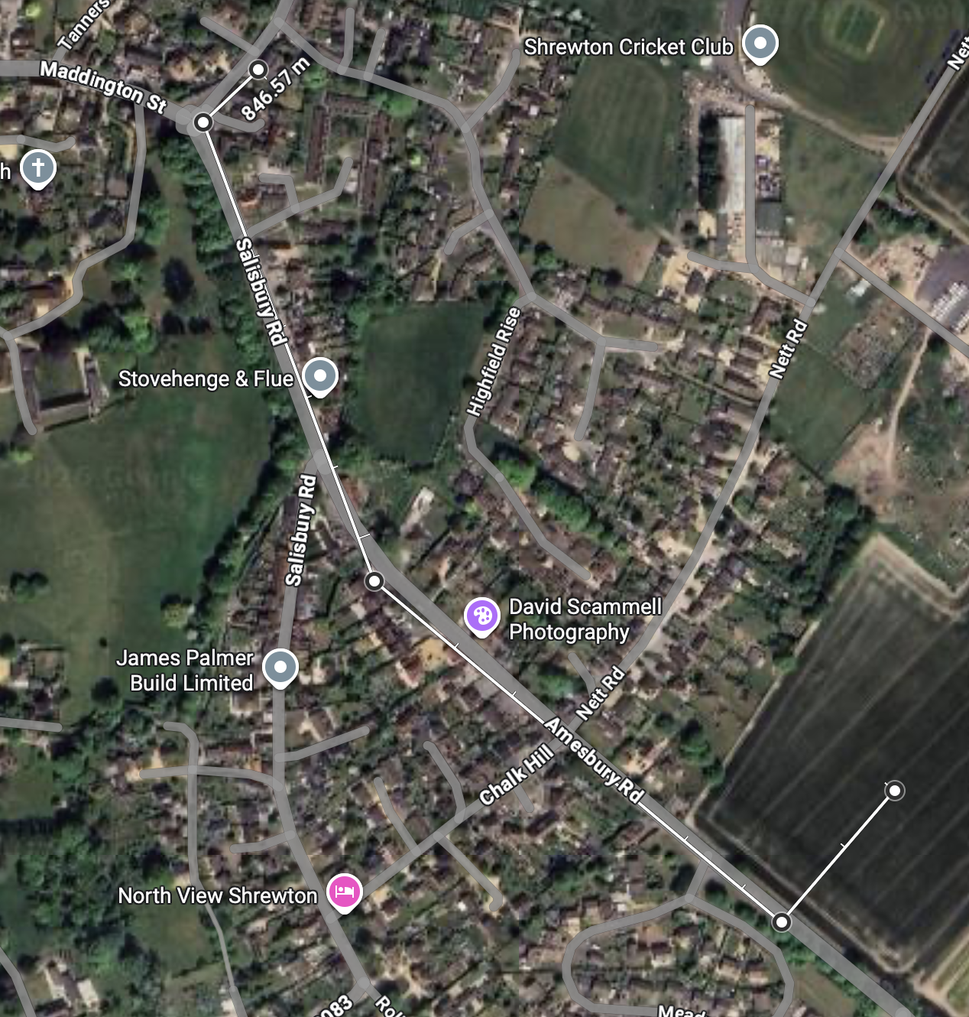  847m
Bus /Tram Stop | <400m  400-800m  >800m |  | 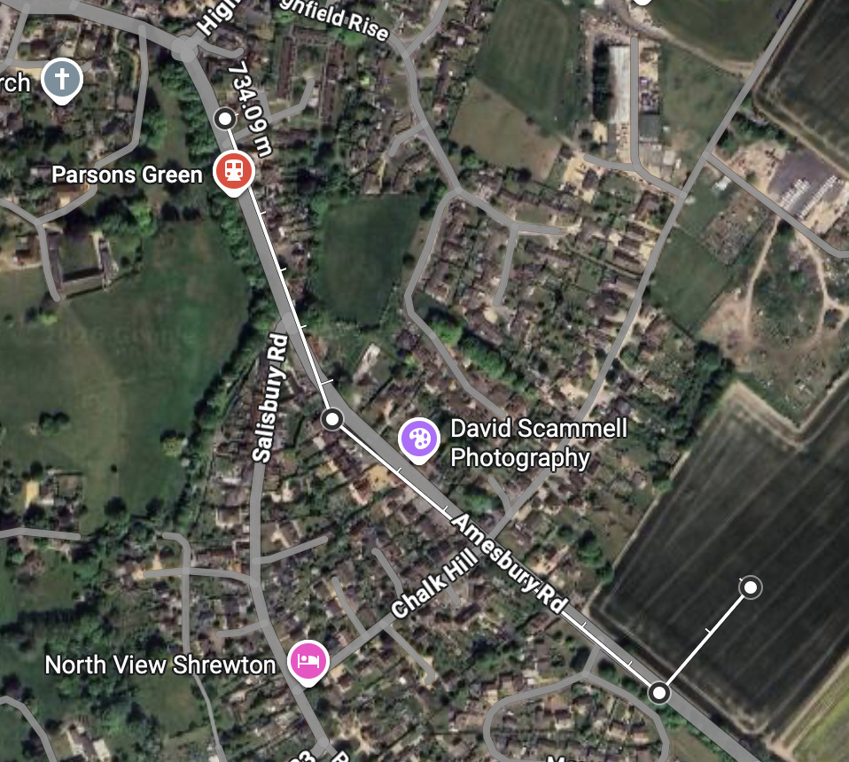  734m
Train station | <400m  400-1200m  >1200m |  | >1200m
Primary School | <400m  400-1200m  >1200m |  | 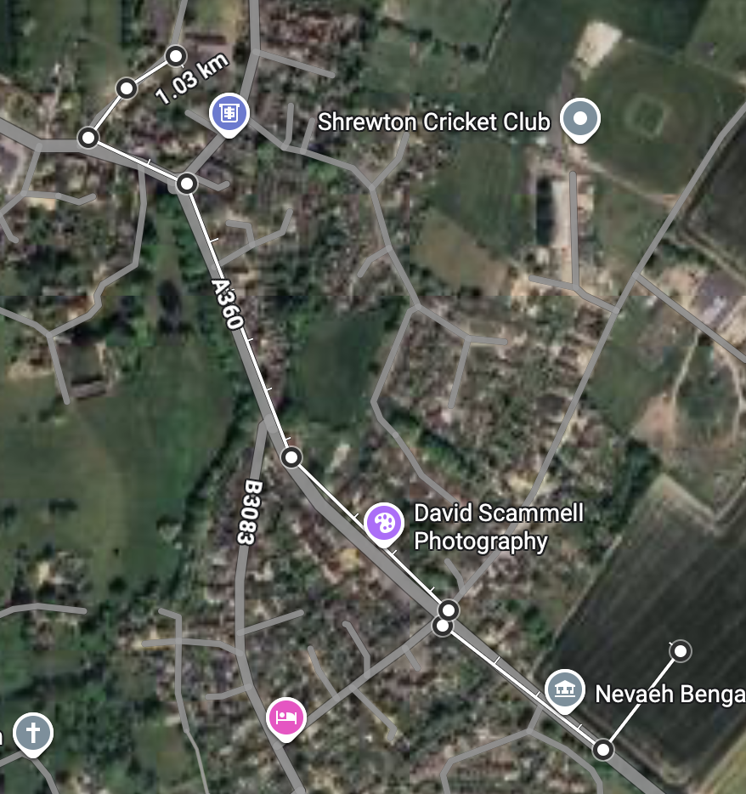  1.03km
Secondary School | <1600m  1600-3900m  >3900m |  | >3900m
Open Space / recreation facilities | <400m  400-800m  >800m |  | 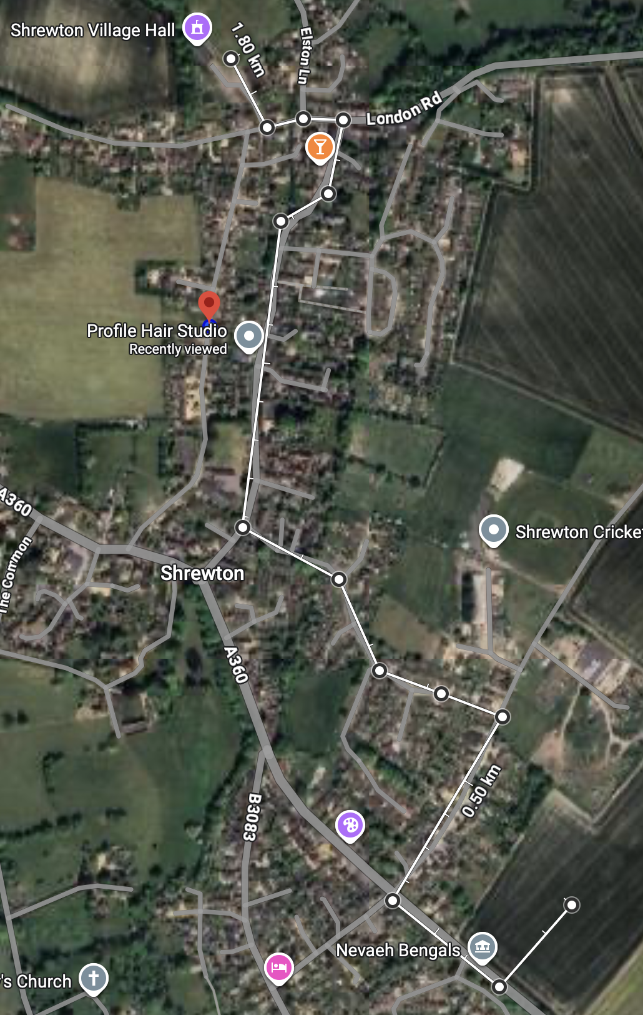  1.8km
Cycle Route | <400m  400-800m  >800m |  | 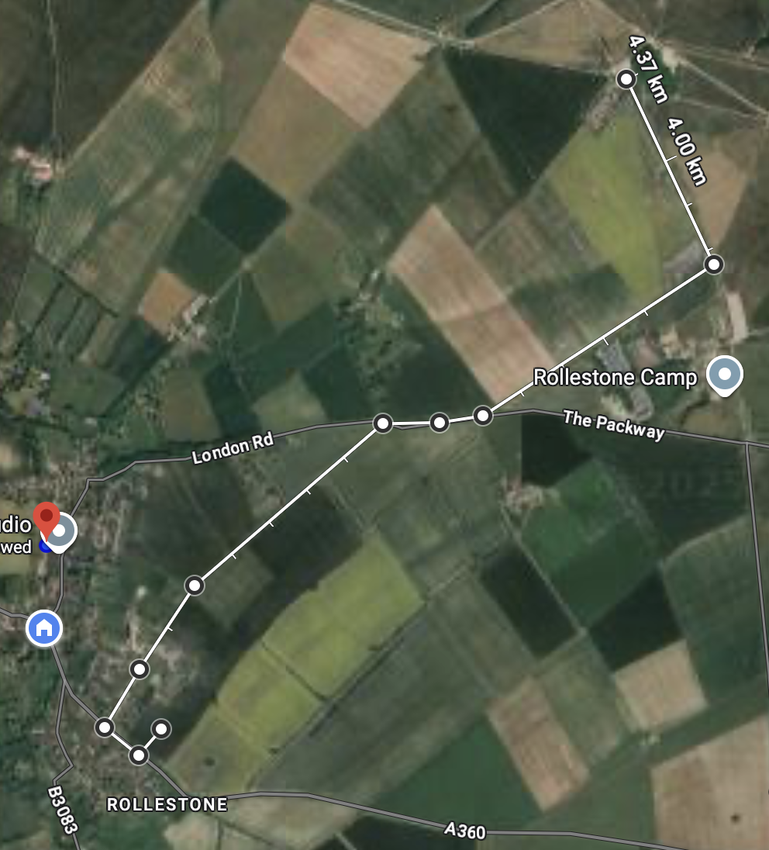 King Alfred’s Way

Landscape and Visual Constraints
This section should be answered based on existing evidence (see guidance notes) or by a qualified landscape consultant.
Indicator of Suitability | Assessment
Is the site low, medium or high sensitivity in terms of landscape?  Low sensitivity: the site has few or no valued features, and/or valued features that are less susceptible to development and can accommodate change.  Medium sensitivity: the site has many valued features, and/or valued features that are susceptible to development but could potentially accommodate some change with appropriate mitigation.  High sensitivity: the site has highly valued features, and/or valued features that are highly susceptible to development. The site can accommodate minimal change. | Medium–High  D3: LARKHILL CHALK DOWNLAND  This patchwork of arable farmland and calcareous grassland includes several sensitive landscape  elements, such as numerous archaeological features, mixed woodland copses and shelterbelts, which contribute to a diverse, yet large-scale landscape pattern. Overlying settlement pattern is small-scale and sense of tranquillity is strong throughout most of the area, at distance from the main A303 and A345 road corridors. Sense of tranquillity is, however, often disturbed by military training activities.  Overall landscape character sensitivity is therefore considered to be moderate to high  Subject to Landscape and Visual Impact Assessment Report
Is the site low, medium or high sensitivity in terms of visual amenity?  Low sensitivity: the site is visually enclosed and has low intervisibility with the surrounding landscape, and/or it would not adversely impact any identified views.  Medium sensitivity: the site is somewhat enclosed and has some intervisibility with the surrounding landscape, and/or it may adversely impact any identified views.  High sensitivity: the site is visually open and has high intervisibility with the surrounding landscape, and/or it would adversely impact any recognised views. | High ³²  Sense of openness within this elevated landscape is strong, resulting in frequent wide panoramic views across open Chalk Downland. At the eastern and western edges of the area, views into the adjacent Till and Upper Avon river valleys are framed by riverside vegetation. Open views towards landmark features, such as Stonehenge and other archaeological monuments also contribute to the visual character of this area. Intervisibility with surrounding areas of chalk downland is strong and generally  seemless. {seamless}  Overall visual sensitivity is considered to be high.  Subject to Landscape and Visual Impact Assessment Report  Subject to Key View Report

Heritage Constraints
Indicator of Suitability | Assessment
Would the development of the site cause harm to a designated heritage asset or its setting?  Directly impact and/or mitigation not possible  Some impact, and/or mitigation possible  Limited or no impact or no requirement for mitigation | Limited or no impact or no requirement for mitigation.  Local Planning Authority Global Information System / Historic England listings reviewed
Would the development of the site cause harm to a non-designated heritage asset or its setting?  Directly impact and/or mitigation not possible  Some impact, and/or mitigation possible  Limited or no impact or no requirement for mitigation | Limited or no impact or no requirement for mitigation

Planning policy constraints
Indicator of Suitability | Assessment
Is the site in the Green Belt?  Yes / No / Unknown | No
Is the site allocated for a particular use (e.g. housing / employment) or designated as open space in the adopted and / or emerging Local Plan?  Yes / No / Unknown | No  The site was not assessed further following Wiltshire Housing Site Allocations Plan Sustainability Appraisal Report February 2020
Are there any other relevant planning policies relating to the site? | No
Is the site:  Greenfield  A mix of greenfield and previously developed land  Previously developed land? | Greenfield
Is the site within, adjacent to or outside the existing built up area?  Within the existing built up area (infill)?  Adjacent to and connected to the existing built up area?  Outside and not connected to the existing built up area? | Adjacent to and connected to the existing built-up area
Is the site within, adjacent to or outside the existing settlement boundary (if one exists)?  Within the existing settlement boundary?  Adjacent to and connected to the existing settlement boundary?  Outside and not connected to the existing settlement boundary? | Adjacent to and connected to the existing settlement boundary
Would development of the site result in neighbouring settlements merging into one another?  Yes / No / Unknown | No
Is the size of the site large enough to significantly change the size and character of the existing settlement?  Yes / No / Unknown | Yes if developed to full potential (148) would be inconsistent with current village density and add ~17% to village size. However, development will be constrained initially to meeting the residual housing requirement of 72.

Assessment of Availability
Indicator of Availability | Assessment
Is the site available for development?  Yes / No / Unknown. | Yes
Are there any known legal or ownership problems such as unresolved multiple ownerships, ransom strips, tenancies, or operational requirements of landowners?  Yes / No / Unknown. | No
Is there a known time frame for availability?  Available now / 0-5 years / 6-10 years / 11-15 years. | Available now. However, see SWWRC constraint that likely precludes development before 2030

Viability
Indicators of Viability | Assessment
Is the site subject to any abnormal costs that could affect viability, such as demolition, land remediation or relocating utilities?  Yes / No / Unknown.  What evidence is available to support this judgement? | Yes  Mitigation required for safe traffic access to A360 and non-vehicular user routes to village centre.  There are plans for the local sewage treatment works to be upgraded to improve nutrient management, but this is not likely to be complete until 2030. Due to the likely limited options available to address phosphorus neutrality in the short term, planned development at Shrewton may not be achievable until the latter end of the Local Plan period, unless development proposals can demonstrate an acceptable bespoke mitigation strategy.  Development at these settlements (inc Shrewton)could potentially contribute towards LSE on the River Avon SAC through abstraction and mitigation could be required.  Viability assessment should be repeated to take account of the significant constraint mitigations required

Conclusions
Conclusions | Assessment

Summary of key development constraints affecting the site | The site is affected by a number of significant constraints, which materially influence its suitability, scale, and timing of development:  Ecology and European sites: The site lies within 5km of the Salisbury Plain SPA and Hampshire Avon SAC and within the Impact Risk Zone of the River Till SSSI. Residential development would require Habitats Regulations Assessment screening and, if necessary, Appropriate Assessment. Development is dependent on the identification and delivery of suitable mitigation to avoid adverse effects on site integrity.  Wastewater and nutrient constraints: Development is likely to be constrained by wastewater treatment capacity and nutrient neutrality requirements. Current evidence indicates that upgrades to relevant sewage treatment infrastructure may not be completed until around 2030. Unless a suitable bespoke mitigation strategy can be demonstrated, this constraint is likely to delay delivery.  Highways and access: Vehicular access onto the A360 represents a major constraint. Any development would require a proportionate Transport Assessment or Transport Statement to demonstrate safe and suitable access, including junction capacity, road safety, and non-motorised user mitigation measures, to the satisfaction of the local highways authority.  Landscape and visual impact: The site has moderate–high landscape sensitivity and high visual sensitivity, occupying a prominent village-edge location with strong intervisibility from the surrounding chalk downland. Development would require a reduced scale, lower density, and a comprehensive landscape mitigation framework to limit visual and landscape impacts.  Accessibility and sustainability: The site is located over 1km walking distance from most key village services and facilities, with significant changes in level and road safety constraints. The location is therefore less sustainable than more centrally located sites and would be likely to generate a higher reliance on private car travel.  Agricultural land: Evidence on agricultural land classification is conflicting. Should the site be confirmed as best and most versatile agricultural land (Grades 1–3a), its loss would represent a policy constraint that would need to be justified through comparison with reasonable alternative sites.

What is the estimated development capacity of the site? | Based on the scale of constraints, landscape sensitivity, and the residual housing requirement, a reduced indicative capacity of approximately 72 dwellings is considered more realistic than higher yield scenarios, subject to detailed design and mitigation.
What is the likely timeframe for development?  (0-5 / 6-10 / 11-15 / 15+ years) | The site is not currently deliverable within the first five years of the plan period due to unresolved wastewater capacity and nutrient mitigation constraints and the need for further technical assessments.  The site is considered developable in the medium term (6–10 years), subject to:  Confirmation of an acceptable ecological mitigation strategy;  Resolution of wastewater and nutrient constraints;  Demonstration of safe and suitable highway access;  Delivery of appropriate landscape and visual mitigation.
Other key information | Available – Yes  Achievable – Yes (Residential)  Deliverable No - Available in land ownership terms; not deliverable within the first five years of the plan period ldue to infrastructure and environmental constraints
Overall rating (Red/Amber/Green)  The site is suitable, available and achievable  The site is potentially suitable, available and achievable  The site is not currently suitable, available and achievable | Suitable: The site is potentially suitable for residential development in principle, but only subject to the resolution of significant environmental, infrastructure, highways, and landscape constraints. These constraints materially affect the form, scale, and timing of development.  Available: The site is considered available, with no known legal or ownership constraints and the landowner indicating that the site could be brought forward.  Achievable / Viable: The site is potentially achievable, however abnormal costs associated with access works, landscape mitigation, non-motorised user provision, ecological mitigation, and wastewater/nutrient solutions may affect viability and require further assessment.  Amber – Potentially suitable, available and developable (6–10 years), subject to significant mitigation and infrastructure delivery.
Summary of justification for rating | Smaller site than S150/S146 but still constrained by A360 access, ecology, sewage and water constraints and settlement edge effects.

S154 Land to the South of London Road, Shrewton
Detail | Assessment
Land to the south of London Road, Shrewton
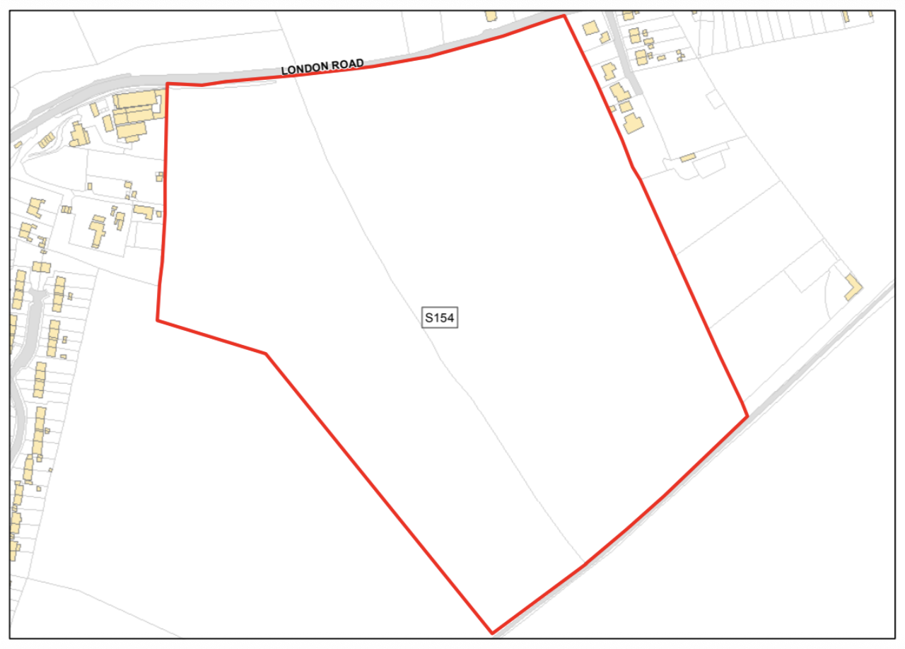 | 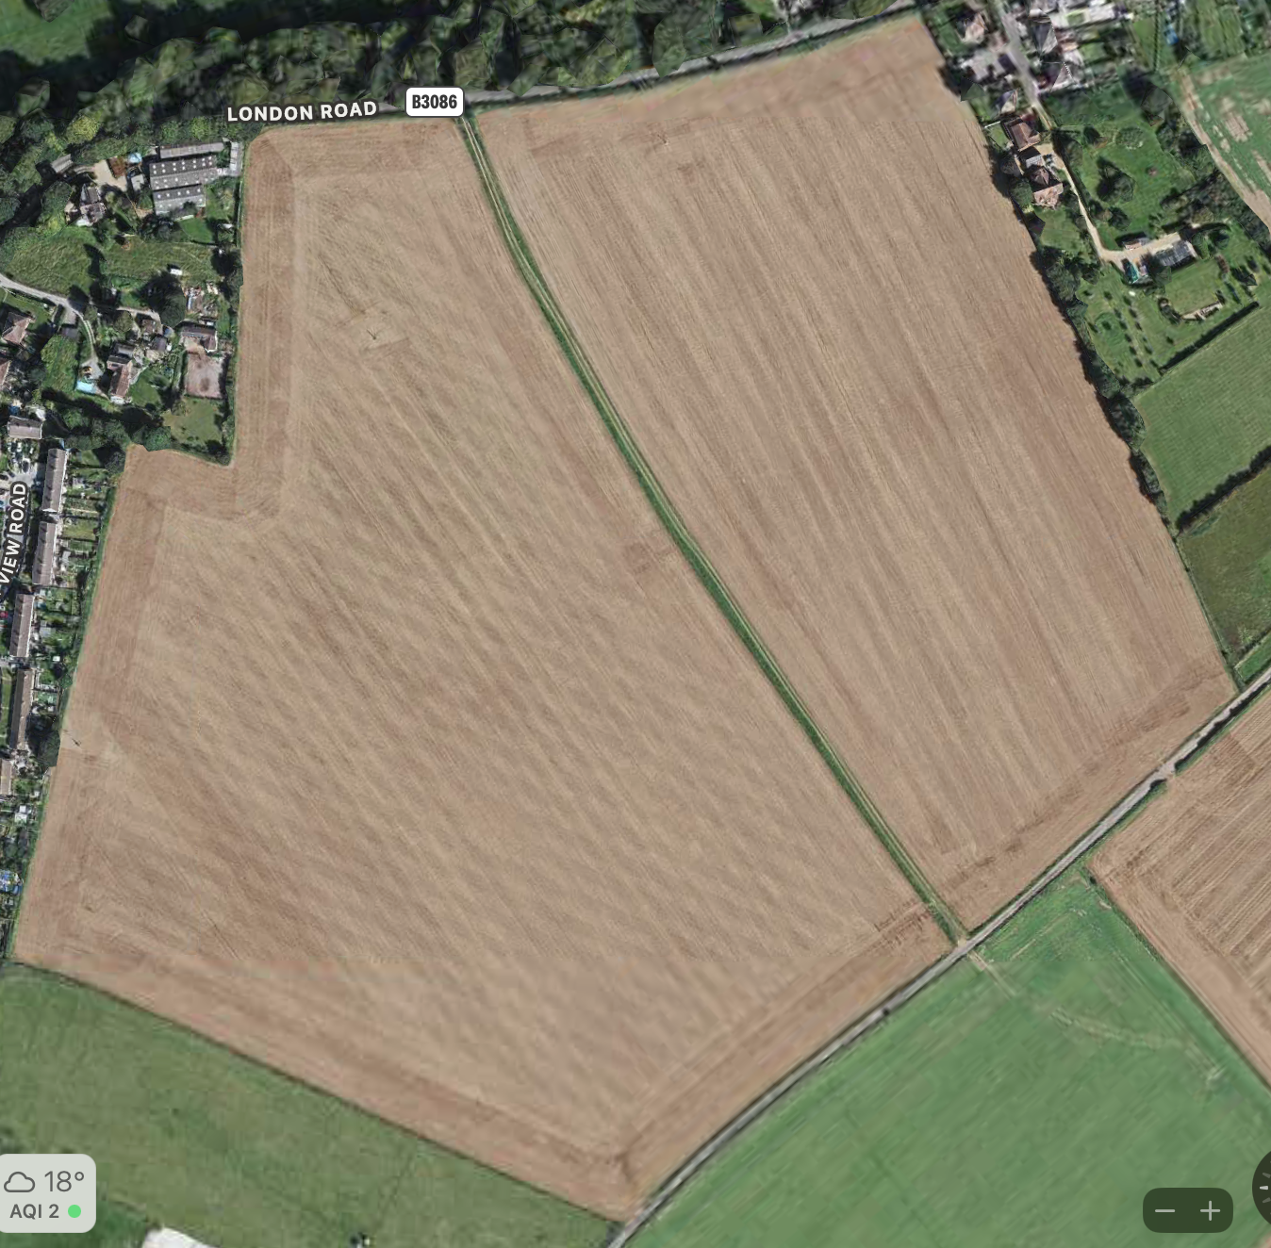
Site Address / Location | Land to the south of London Road, Shrewton
Gross Site Area (Hectares) | 13.352ha (100% suitable)
SHLAA/SHELAA Reference (if applicable) | Shrewton - S154
Existing land use | Greenfield
Land use being considered, if known (e.g. housing, community use, commercial, mixed use) | Residential 72. Constrained by residual housing requirement for Shrewton (Rural Settlement Housing Requirements (Jul 2023)
Landowner estimate of development capacity (if known) | Developer Proposal 190. (A Vision for Shrewton. November 2023).
Site identification method / source  (e.g. SHELAA, Call for Sites consultation, identified by neighbourhood planning group) | WC Documents: SHELAA02SHELAA  Appendix51AmesburyCommunityArea.pdf 5.pdf
Planning history  (Live or previous planning applications/decisions) | 19/11113/OUT up to 9 dwellings –  not taken forward.S154 (Part)
Neighbouring uses | Greenfield/Residential

Assessment of Suitability

Environmental Constraints
Indicator of Suitability | Assessment
Site is predominantly, or wholly, within or adjacent to the following statutory environmental designations:  Ancient Woodland  Area of Outstanding Natural Beauty (AONB)  Biosphere Reserve  Local Nature Reserve (LNR)  National Nature Reserve (NNR)  National Park  Ramsar Site  Site of Special Scientific Interest (SSSI)  Special Area of Conservation (SAC)  Special Protection Area (SPA)  Yes/ No/ Unknown  Does the site fall within a SSSI Impact Risk Zone and would the proposed use/development trigger the requirement to consult Natural England?  Yes/ No/ Unknown | Yes  Site is within SPA_5km, SAC_5km, SSSI_2km, Significant mitigations will be required to support any development on this site.  Within 2km of River Till SSSI (~500m at closest point . Development requires Natural England consultation (Source https://magic.defra.gov.uk/MagicMap.html within SSSI Impact Risk Zones. (Accessed Jan 2026))
Site is predominantly, or wholly, within or adjacent to the following non statutory environmental designations:  Green Infrastructure Corridor  Local Wildlife Site (LWS)  Public Open Space  Site of Importance for Nature Conservation (SINC)  Nature Improvement Area  Regionally Important Geological Site  Other  Yes/ No/ Unknown | No
Site is predominantly, or wholly, within Flood Zones 2 or 3?  See guidance notes:  Flood Zone 1: Low Risk  Flood Zone 2: Medium Risk  Flood Zone 3 (less or more vulnerable site use): Medium Risk  Flood Zone 3 (highly vulnerable site use): High Risk | Low Risk  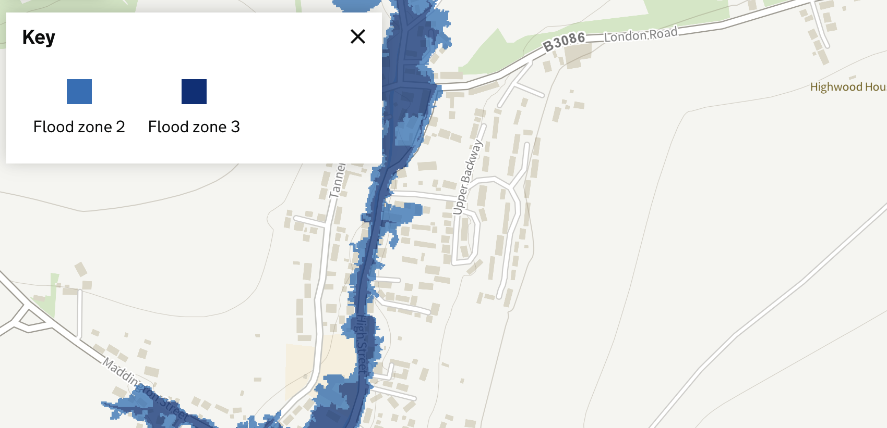
Site is at risk of surface water flooding?  See guidance notes:  Less than 15% of the site is affected by medium or high risk of surface water flooding – Low Risk  >15% of the site is affected by medium or high risk of surface water flooding – Medium Risk | Low Risk  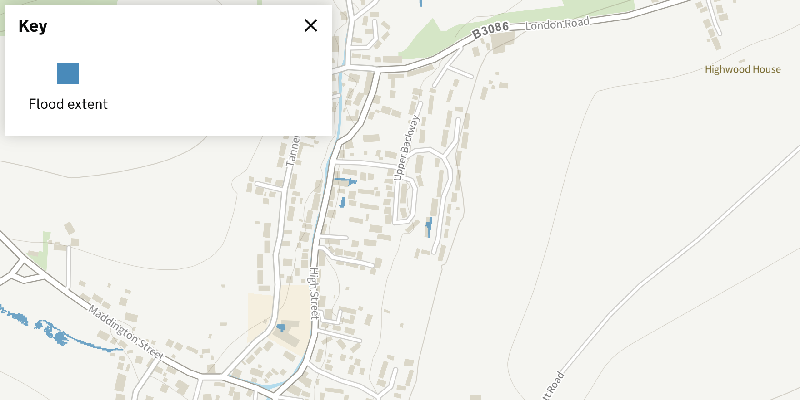
Is the land classified as the best and most versatile agricultural land (Grades 1, 2 or 3a)  Yes / No / Unknown | Unknown:  There is a conflict between the Rural Housing Requirements (Jul 2023): ALCG3 and the SHELAA: ALCG1.  Local farming assessment suggests 3B  A formal assessment may be required if BMV becomes a deciding factor.
Site contains habitats with the potential to support priority species?  Does the site contain local wildlife-rich habitats?  Is the site part of:  A wider ecological network (including the hierarchy of international, national and locally designated sites of importance for biodiversity);  wildlife corridors (and stepping stones that connect them); and/or  An area identified by national and local partnerships for habitat management, enhancement, restoration or creation?  Yes / No / Unknown | Yes  1. The site is within the Hampshire Avon SAC and the Salisbury Plain SPA both of which are considered of European importance.  2. The site is also within the Risk Impact Zone for the River Till SSSI which is considered of national importance.  Strategic Environmental Assessment and Habitats Regulation Assessment are both likely to be required.
Site is predominantly, or wholly, within or adjacent to an Air Quality Management Area (AQMA)?  Yes / No / Unknown | No

Physical Constraints
Indicator of Suitability | Assessment
Is the site:  Flat or relatively flat  Gently sloping or uneven  Steeply sloping | Gently sloping or uneven
Is there existing vehicle access, or potential to create vehicle access to the site?  Yes / No / Unknown | Yes  Any development of the site would be required to be supported by a proportionate Transport Assessment or Transport Statement, including junction capacity and safety analysis for access onto the B3086, with any necessary mitigation to be agreed with the local highway’s authority.
Is there existing pedestrian/cycle access, or potential to create pedestrian/cycle access to the site?  Pedestrian?  Yes / No / Unknown  Cycle?  Yes / No / Unknown | Yes  Site would require cycle and footpath(s) to improve connectivity to village.
Are there any known Tree Preservation Orders on the site?  Yes / No / Unknown | No
Are there veteran/ancient or other significant trees within or adjacent to the site? Are they owned by third parties?  Significant trees?  Yes, within / Yes, adjacent / No / Unknown  Potentially veteran or ancient trees present?  Yes, within / Yes, adjacent / No / Unknown  Owned by third parties?  Yes / No / Unknown | No  No  No
Are there any Public Rights of Way (PRoW) crossing the site?  Yes / No / Unknown | Yes SHRE 1  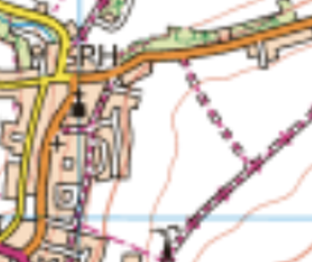
Is the site likely to be affected by ground contamination?  Yes / No / Unknown | No
Is there any utilities infrastructure crossing the site i.e. power lines/pipe lines, or is the site in close proximity to hazardous installations?  Yes / No / Unknown | Wessex Water 4in Main (Along B3086)(See 19/11113/OUT for details)
Would development of the site result in a loss of social, amenity or community value?  Yes / No / Unknown | No

Accessibility
Factor |  | Guidance
Distances to community facilities and services should be measured using walking routes from the centre of each site to each facility. Additional facilities can be added to the list. The distances are based on the assumption that 400m is equal to approximately 5 minutes’ walk. This can be measured using Google Maps:
What is the distance to the following facilities (measured from the edge of the site) | Distance  (metres) |  | Comments
Town / local centre / shop | <400m  400-1200m  >1200m |  | 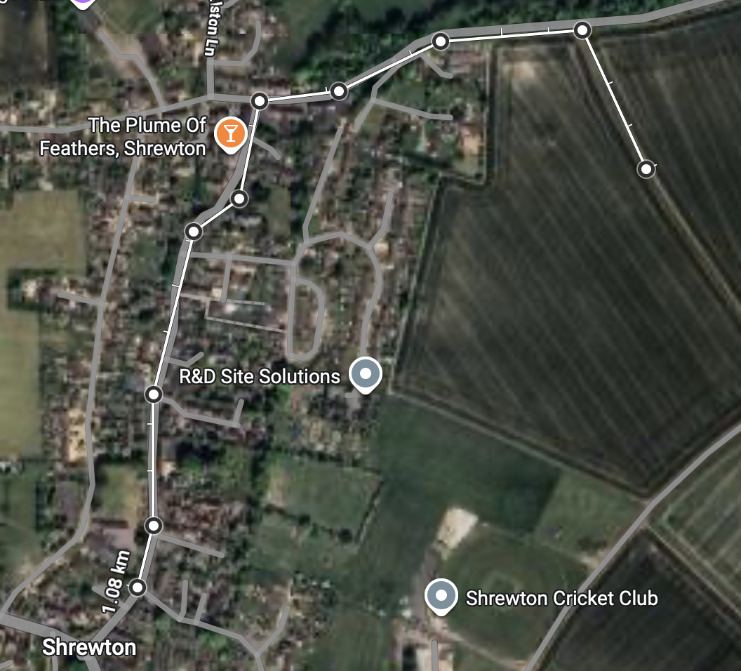  1080m or  1170m via Nett Rd/Chapel Lane
Bus /Tram Stop | <400m  400-800m  >800m |  | 1080km  1170 via Nett Rd/Chapel Lane
Train station | <400m  400-1200m  >1200m |  | Salisbury>1200m
Primary School | <400m  400-1200m  >1200m |  | 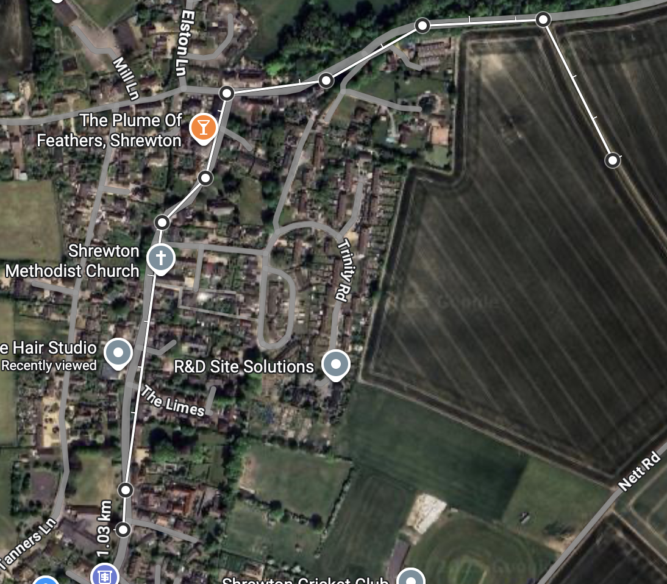  1.03Km
Secondary School | <1600m  1600-3900m  >3900m |  | Amesbury>3900m
Open Space / recreation facilities | <400m  400-800m  >800m |  | 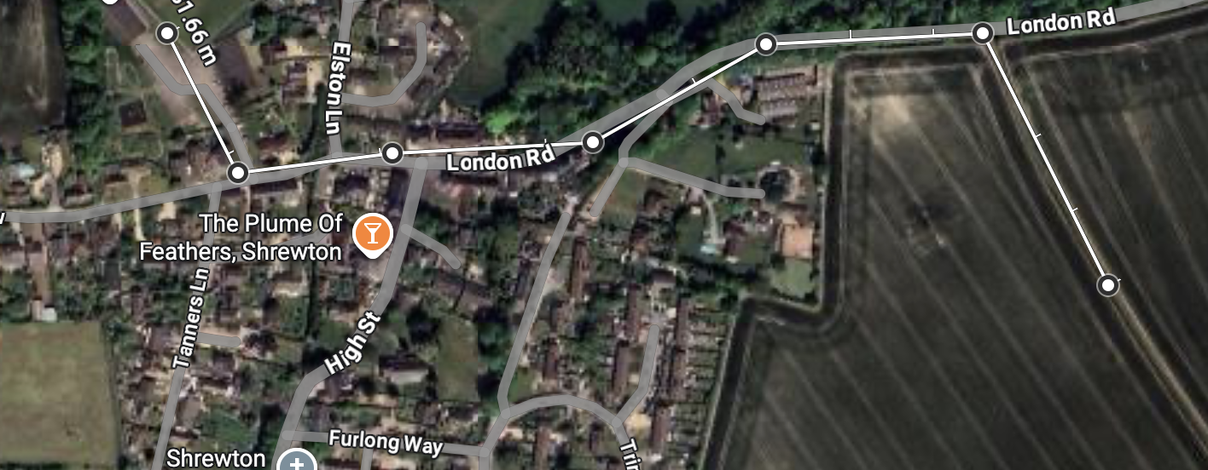 693m The Rec
Cycle Route | <400m  400-800m  >800m |  | King Alfred’s Way>800m

Landscape and Visual Constraints
This section should be answered based on existing evidence (see guidance notes) or by a qualified landscape consultant.
Indicator of Suitability | Assessment
Is the site low, medium or high sensitivity in terms of landscape?  Low sensitivity: the site has few or no valued features, and/or valued features that are less susceptible to development and can accommodate change.  Medium sensitivity: the site has many valued features, and/or valued features that are susceptible to development but could potentially accommodate some change with appropriate mitigation.  High sensitivity: the site has highly valued features, and/or valued features that are highly susceptible to development. The site can accommodate minimal change. | Medium to high:  D3: LARKHILL CHALK DOWNLAND  This patchwork of arable farmland and calcareous grassland includes several sensitive landscape  elements, such as numerous archaeological features, mixed woodland copses and shelterbelts, which contribute to a diverse, yet large-scale landscape pattern. Overlying settlement pattern is small-scale and sense of tranquillity is strong throughout most of the area, at distance from the main A303 and A345 road corridors. Sense of tranquillity is, however, often disturbed by military training activities.  Overall landscape character sensitivity is therefore considered to be moderate to high  Subject to Landscape and Visual Impact Assessment Report  Note: Building on higher section of site (adjacent to Nett Rd) may conflict with WHS Supplementary Planning Document.
Is the site low, medium or high sensitivity in terms of visual amenity?  Low sensitivity: the site is visually enclosed and has low intervisibility with the surrounding landscape, and/or it would not adversely impact any identified views.  Medium sensitivity: the site is somewhat enclosed and has some intervisibility with the surrounding landscape, and/or it may adversely impact any identified views.  High sensitivity: the site is visually open and has high intervisibility with the surrounding landscape, and/or it would adversely impact any recognised views. | High  Sense of openness within this elevated landscape is strong, resulting in frequent wide panoramic views across open Chalk Downland. At the eastern and western edges of the area, views into the adjacent Till and Upper Avon river valleys are framed by riverside vegetation. Open views towards landmark features, such as Stonehenge and other archaeological monuments also contribute to the visual character of this area. Intervisibility with surrounding areas of chalk downland is strong and generally  seemless.  Overall visual sensitivity is assessed as high.  Subject to Landscape and Visual Impact Assessment Report  Subject to Key View Report

Heritage Constraints
Indicator of Suitability | Assessment
Would the development of the site cause harm to a designated heritage asset or its setting?  Directly impact and/or mitigation not possible  Some impact, and/or mitigation possible  Limited or no impact or no requirement for mitigation | Some impact, and/or mitigation possible  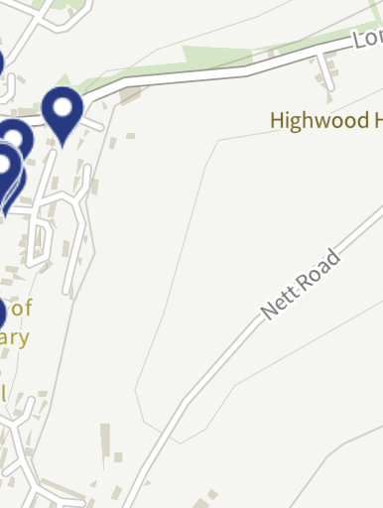  The site does not contain any designated heritage assets. However, this is the only site where development could approach local ridge lines and as with all Shrewton sites, it lies within the wider setting of the Stonehenge World Heritage Site. Therefore, parts of the site—particularly the higher ground adjacent to Nett Road—have the potential to affect the appreciation of the WHS and its associated archaeological landscape.  The assessment recognises that development extending onto elevated sections of the site could conflict with the guidance set out in the Stonehenge World Heritage Site Supplementary Planning Document, particularly in relation to openness and long-distance views across the chalk downland landscape.  Nevertheless, it is considered that limited development confined to the lower and less visually prominent parts of the site, avoiding the ridge line, and incorporating substantial green infrastructure and landscape buffering, may be capable of avoiding unacceptable harm to the significance of the WHS and its setting. Any future development would need to be supported by a Landscape and Visual Impact Assessment and an assessment of effects on the WHS setting to confirm that impacts are appropriately mitigated.  On this basis, impacts on heritage assets, are assessed as potentially mitigable, rather than insurmountable, subject to further evidence and careful site design.
Would the development of the site cause harm to a non-designated heritage asset or its setting?  Directly impact and/or mitigation not possible  Some impact, and/or mitigation possible  Limited or no impact or no requirement for mitigation | Limited or no impact or no requirement for mitigation

Planning policy constraints
Indicator of Suitability | Assessment
Is the site in the Green Belt?  Yes / No / Unknown | No
Is the site allocated for a particular use (e.g. housing / employment) or designated as open space in the adopted and / or emerging Local Plan?  Yes / No / Unknown | No  The site was not assessed further following Wiltshire Housing Site  Allocations Plan Sustainability Appraisal Report February 2020
Are there any other relevant planning policies relating to the site? | None in SHELAA or Wiltshire Council Planning Site (Jan 2026)
Is the site:  Greenfield  A mix of greenfield and previously developed land  Previously developed land? | Greenfield
Is the site within, adjacent to or outside the existing built up area?  Within the existing built up area (infill)?  Adjacent to and connected to the existing built up area?  Outside and not connected to the existing built up area? | Adjacent to and connected to the existing built up area?
Is the site within, adjacent to or outside the existing settlement boundary (if one exists)?  Within the existing settlement boundary?  Adjacent to and connected to the existing settlement boundary?  Outside and not connected to the existing settlement boundary? | Adjacent to and connected to the existing settlement boundary?
Would development of the site result in neighbouring settlements merging into one another?  Yes / No / Unknown | No
Is the size of the site large enough to significantly change the size and character of the existing settlement?  Yes / No / Unknown | Yes. If fully developed (190 houses). However, development of >72 houses would extend the village along the London Rd. Advantage is that it would connect existing London Rd houses with village.

Assessment of Availability
Indicator of Availability | Assessment
Is the site available for development?  Yes / No / Unknown. | Yes
Are there any known legal or ownership problems such as unresolved multiple ownerships, ransom strips, tenancies, or operational requirements of landowners?  Yes / No / Unknown. | No
Is there a known time frame for availability?  Available now / 0-5 years / 6-10 years / 11-15 years. | Available now. However, see SWWRC constraint that likely precludes development before 2030

Viability
Indicators of Viability | Assessment
Is the site subject to any abnormal costs that could affect viability, such as demolition, land remediation or relocating utilities?  Yes / No / Unknown.  What evidence is available to support this judgement? | Yes.  Developing to the ridge line may infringe Stonehenge Sightlines. Mitigation possible by keeping development to lower slopes and would require green infrastructure (trees/hedges)  Access to the site would be via B3086 which would add traffic to this busy B road but the junction could slow through traffic on B3086  Site is within SCA/SPA and will require mitigation.  Within SSSI IRZ and will require Natural England Consultation.  There are plans for the local sewage treatment works to be upgraded to improve nutrient management, but this is not likely to be complete until 2030. Due to the likely limited options available to address  phosphorus neutrality in the short term, planned development at Shrewton may not  be achievable until the latter end of the Local Plan period, unless development  proposals can demonstrate an acceptable bespoke mitigation strategy.  Development at these settlements (inc Shrewton)could potentially contribute towards LSE on the River Avon SAC through abstraction and mitigation could be required.  Investment into surface water mitigation measures will be required as the underlying geology is likely to prevent the implementation of Sustainable Drainage Systems.  Viability assessment should be repeated to take account of the significant constraint mitigations required.

Conclusions | Assessment
Summary of key development constraints affecting the site | Ecology, Water, Sewage and landscape constraints.  Available - Yes  Achievable - Yes (residential)  Deliverable: - No  Developable: Developable: 6–10 years (subject to wastewater upgrade and nutrient mitigation)
What is the estimated development capacity of the site? | Indicative neighbourhood-plan scale development: up to the residual housing requirement (currently 72 dwellings), subject to constraints.
What is the likely timeframe for development?  (0-5 / 6-10 / 11-15 / 15+ years) | 6-10 years.  Due to the combination of nutrient neutrality requirements, the need for bespoke mitigation, and the wastewater infrastructure upgrade timetable, the site cannot be considered deliverable within the first five years of the plan period.  While development may become achievable later in the plan period, this is dependent on:  - Completion of wastewater infrastructure upgrades,  - Resolution of nutrient mitigation requirements, and  - The ability to demonstrate acceptable landscape, ecological and highway mitigation without undermining viability.

Other key information
Overall rating (Red/Amber/Green)  The site is suitable, available and achievable  The site is potentially suitable, available and achievable  The site is not currently suitable, available and achievable | Suitable: The site is potentially suitable for residential development in principle, but only subject to the resolution of significant environmental, infrastructure, highways, and landscape constraints. These constraints materially affect the form, scale, and timing of development.  Available: The site is considered available, with no known legal or ownership constraints and the landowner indicating that the site could be brought forward.  Achievable / Viable: The site is potentially achievable, however abnormal costs associated with access works, ecological mitigation, and wastewater/nutrient solutions may affect viability and require further assessment.  Amber – Potentially suitable, available and developable (6–10 years), subject to significant mitigation and infrastructure delivery.
Summary of justification for rating | Suitable in principle, but significantly constrained;  Available, but subject to uncertainty regarding timing; and  Not deliverable within years 0–5, but potentially developable, subject to further evidence and mitigation.

The NPPF has been updated to 2025 standard, but these changes do not affect NPs. A new version of the NPPF is out for consultation (until Mar 2026) and is expected to be released summer of 2026. NPs that reach Submission after then, will have to ensure that policies align with the new NPPF.
https://Shrewton.gov.uk/guidance/housing-and-economic-land-availability-assessment
https://Shrewton.gov.uk/guidance/neighbourhood-planning--2
https://neighbourhoodplanning.org/toolkits-and-guidance/assess-allocate-sites-development/
: https://neighbourhoodplanning.org/toolkits-and-guidance/assess-allocate-sites-development/
https://www.wiltshire.gov.uk/media/372/Wiltshire-Core-Strategy-adopted-2015/pdf/Wiltshire_Core_Strategy_2015.pdf?m=1735555642237 ⁸ https://wiltscouncil.maps.arcgis.com/apps/webappviewer/index.html?id=8175cb711fd94b338e2b9f748c4e91f2
https://www.wiltshire.gov.uk/article/1081/Wiltshire-Housing-Site-Allocations-Plan
https://www.wiltshire.gov.uk/media/12017/Rural-Housing-Requirements-2023/pdf/Rural_Housing_Requirements_2023.pdf?m=1695745988247
https://017f5bf8-ff4d-415b-be58-79dae2836c33.usrfiles.com/ugd/017f5b_e8cc57a20c6149e7a168a7435379655e.pdf (Nov 2025)
Earlier residual requirements figures appear to stem from differences in completions and an apparent mathematical error 82-16 does not = 69!!
https://www.wiltshire.gov.uk/media/11976/Wiltshire-Local-Plan-Pre-Submission-Draft-2020-2038-Regulation-19/pdf/Wiltshire_Local_Plan_Reg_19_web_accessible_version.pdf?m=1695730562743
https://017f5bf8-ff4d-415b-be58-79dae2836c33.usrfiles.com/ugd/017f5b_7c5e368dae2548949cf9ff01a36096ac.pdf
https://publications.naturalengland.org.uk/publication/4982167238344704
https://www.wiltshire.gov.uk/media/9708/South-Wiltshire-Landscape-Character-Assessment-1-25-000/pdf/landscape-character-assessment-full.pdf?m=1732541484297
St_Philips_Land_Ltd_22_11_23_A_vision_for_Shrewton_Vision_Document
https://flood-map-for-planning.service.gov.uk/map?cz=406820,143879,15 (Accessed Jan 2026)
https://check-long-term-flood-risk.service.gov.uk/risk#(Accessed (Accessed Jan 2026)
BMV Agricultural land
https://experience.arcgis.com/experience/88c3030c2e864645aaec7dc3e0ac4cb6/page/Page#data_s=id%3AdataSource_3-190bc4031b8-layer-28-24%3A1 (Accessed Jan 2026).
https://ati.woodlandtrust.org.uk/tree-search/?v=2936011&ml=map&z=15.769104356847105&nwLat=51.19892441987227&nwLng=-1.9100560502913595&seLat=51.19442705266886&seLng=-1.8995677738642485 (Accessed Jan 2026)
https://www.wiltshire.gov.uk/media/9708/South-Wiltshire-Landscape-Character-Assessment-1-25-000/pdf/landscape-character-assessment-full.pdf?m=1732541484297
https://historicengland.org.uk/listing/the-list/results/?q=Shrewton&size=n_24_n (accessed Jan 2026)
Rural Housing Requirements July 2023
https://experience.arcgis.com/experience/88c3030c2e864645aaec7dc3e0ac4cb6/page/Page (Accessed Jan 2026)
St_Philips_Land_Ltd_22_11_23_Land_at_Amesbury_Road_Vision_Document Nov 2023.
https://flood-map-for-planning.service.gov.uk/map?cz=406820,143879,15 (Accessed Jan 2026)
https://check-long-term-flood-risk.service.gov.uk/risk#(Accessed (Accessed Jan 2026)
BMV Agricultural land
https://explore.osmaps.com/?lat=51.19036&lon=-1.89662&zoom=14.8169&style=Leisure&type=2d Accessed Jan 2026
https://experience.arcgis.com/experience/88c3030c2e864645aaec7dc3e0ac4cb6/page/Page#data_s=id%3AdataSource_3-190bc4031b8-layer-28-24%3A1 (Accessed Jan 2026).
https://ati.woodlandtrust.org.uk/tree-search/?v=2936011&ml=map&z=15.769104356847105&nwLat=51.19892441987227&nwLng=-1.9100560502913595&seLat=51.19442705266886&seLng=-1.8995677738642485 (Accessed Jan 2026).
https://explore.osmaps.com/?lat=51.19036&lon=-1.89662&zoom=14.8169&style=Leisure&type=2d (Accessed Jan 2026)
South_Wiltshire_Landscape_Character_Assessment_2008_(Shrewton)-_pages_57-200 (P87)
https://historicengland.org.uk/listing/the-list/results/?q=Shrewton&size=n_24_n (accessed Jan 2026)
https://flood-map-for-planning.service.gov.uk/map?cz=406820,143879,15 (Accessed Jan 2026)
https://check-long-term-flood-risk.service.gov.uk/risk#(Accessed (Accessed Jan 2026)
BMV Agricultural land
https://experience.arcgis.com/experience/88c3030c2e864645aaec7dc3e0ac4cb6/page/Page#data_s=id%3AdataSource_3-190bc4031b8-layer-28-1%3A98863&widget_22=text:19%2F11113%2FOUT
https://ati.woodlandtrust.org.uk/tree-search/?v=2936011&ml=map&z=15.769104356847105&nwLat=51.19892441987227&nwLng=-1.9100560502913595&seLat=51.19442705266886&seLng=-1.8995677738642485 (Accessed Jan 2026)
South_Wiltshire_Landscape_Character_Assessment_2008_(Shrewton)-_pages_57-200 (P87)
South_Wiltshire_Landscape_Character_Assessment_2008_(Shrewton)-_pages_57-200 (P87)
https://historicengland.org.uk/listing/the-list/map-search/ (Accessed Jan 2026)
https://www.wiltshire.gov.uk/media/12017/Rural-Housing-Requirements-2023/pdf/Rural_Housing_Requirements_2023.pdf?m=1695745988247
Setting of Stonehenge Avebury WHS_SPD Adopted 21 Oct 2025
Wiltshire Housing Site Allocations Plan Sustainability Appraisal Report February 2020

